High

II. Gr
Richard Mendelson Presents
A Photographer Looks at China
Sunday, May 15 – 2 pm to 4 pm
Albany Public Library
Richard Mendelson has been a photographer all his life. He and his wife traveled to China in 2000 on an Elderhostel trip. They visited Beijing, Shanghai, Xian, Guilin and took a boat down the Yangtze. Richard took a lot of pictures. Come and enjoy a leisurely tour. You will love the scenery!

Northeast NY Chapter Annual Meeting
Picnic and Party
Sunday, June 12 1 pm to 4 pm
The Picnic Location has been changed to Bethelehem Town Park at Elm Ave, Pavillion A (small pavillion), in Delmar, NY.

We will review this year's activities and talk about plans for the future. You’ll get an update on the convention plans and find out how you can help. Everyone is welcome. Members are asked to bring salads and desserts and some chairs.
Contact information
782-0746
If your address label has an apple on it, it means that your membership is up for renewal. Be the “apple of our eye” and renew today! It will save us time and stamps.

Spring is here! We have been enjoying some good weather recently. The bowling and pizza party in March drew big crowds. The attendees all have great fun. The table tennis tournament in April was very competitive and exciting. The potluck dinner after the game was delicious. The event has been held at Mel and Sissy’s for many years. Their hospitality is deeply appreciated.

National Convention Committee has been working diligently. Most of the presenters have been chosen and committed. The Committee is working on many other issues. Your input and/or participation in organizing the Convention is welcome and appreciated.

It is final exam time for the students. I wish you good luck in the exams, and wish you a great summer in whatever you do, be an intern or just enjoy summer vacation.
Date | Day | Event | Page
5/10 | Tues | Steering Committee Meeting – Alb Pub Lib
5/15 | Sun | Richard Mendelson Presents – Albany Library 2-4 pm | 1
6/12 | Sun | Annual Meeting and Picnic 12:30-4:30 pm | 1
6/17 | Fri | Dinner and a Movie – Private Home 7:00 pm | 2
6/19 | Sun | Newsletter Deadline | 3
TBA |  | May Convention Planning Meeting

Quick View Calendar
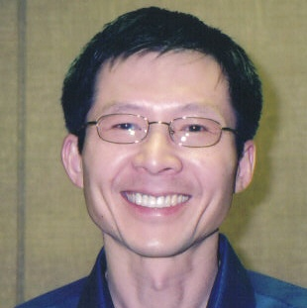
President
Kirk Huang’s
Message

2005 Award Winners
Friendship Builder Award: Longtime member who, over the years, has a record of active participation in the Chapter’s events, plans and programs in helping to improve US-China Friendship and Understanding: 2005 Winner is Karen Dyer (Chapter Secretary for over ten years).
Friendship Links Award: Non-USCPFA member or area organization that has helped to promote US-China Friendship and understanding: 2005 Winners are Steve Barnes, Times Union Editor and William Brantley, Times Union Reporter for his in depth reporting.
Tema Bellinson Memorial Award: As a fitting memorial to longtime teacher and active USCPFA member/organizer, this award is presented to the top area high school student of Chinese language and culture: 2005 Winner is William Cusey, Student of Chinese Language and Culture at Albany High School.

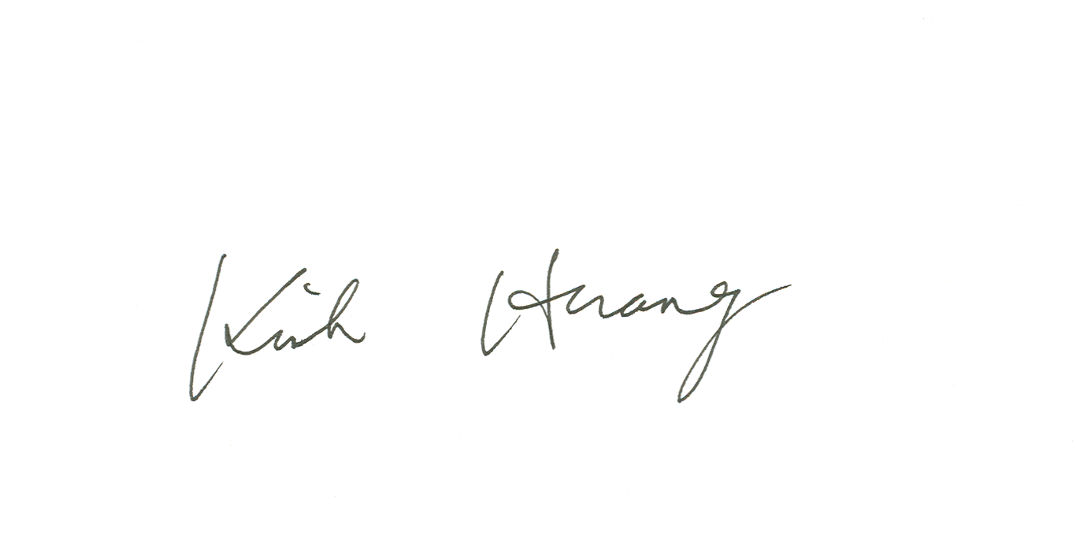

US-China Friendship Newsletter
US-China Peoples Friendship Association
Northeast New York Chapter - Albany

May-June 2005 Vol. 31 Issue 3 www.uscpfany.org

The National Convention Programs – Partial List
Submitted by Gregg Millett
>Film of 1927 Beijing and Presentation on Archiving A-V materials. Bob Brodsky and Toni Treadway, Boston, Massachusetts
>Designing a City in China -- Synthesis Architects, John Senisi and Chuen-Feng Lee, Schenectady, New York
>Chinese Ambivalence: Traditional Wisdom vs. Western Culture -- Shunzhu Wang, Ph.D., Bennington, Vermont
>English and Chinese: The Language Bridge -- Ming Hall, Translation Specialist, Albany, New York
>Democratization in China -- Baohui Zhang, Ph.D., Associate Professor of Government, Daemen College, Buffalo, New York
>Gated Communities in China -- Youqin Huang, Ph.D., Assistant Professor of Geography and Planning, State University of New York at Albany, Albany, New York
>Bridges to Kunming -- Jin Fei Bao, Entrepreneur, Co-Presenter, Kunming, China; Gregg Millett, Ph.D., Co-Presenter, Niskayuna, New York; Krystal Millett-Garrison, Co-Presenter, Guilderland, New York
>US-China: The Challenge of Cultural Exchange -- James Bradley, New York Times Best Selling Author, Rye, New York
>Ordering the Chaotic World: Cosmology and Poetry as the Twin Pillars of Chinese
Civilization -- Alice Cheang, Ph.D., Albany, New York
>Understanding Modern China -- Sidney Gluck, Ph.D., New York, New York
>People, Landscapes, and Conservation in Northwest Yunnan -- Ted Elliman, M.S., Co-Presenter, Albany, New York; Mei He, Co-Presenter, Labo Village (Mosuo) Yunnan, China
>Experiencing Three Years as a Teacher in Taiwan --Eric Kelley, Teacher
>Chinese Brush Painting -- Gu Lefu, Retired Professor and Internationally Known Artist, Albany, New York
>A Search of Sixty Years: American Soldiers Lost in China in WWII -- Wen Jiang, Ph.D., Hamden, Connecticut
>Chinese Shadow Theater -- Fan Pen Chen, Ph.D., Assistant Professor of East Asian Studies, State University of New York at Albany, Albany, New York
>Experiences of American Families who have adopted from China -- Ann Lapinski, adoptive parent of Asian Child, Schenectady, NY
>Journey to Jenna-- A Photographic Exhibit -- Donna Christensen, adoptive parent of Asian child, St. Johnsville, NY
>Telling Traditional Chinese Folktales -- Cathryn Fairlee, Healdsburg, California
>U.S.-China Relations -- Two Steps Forward, One Step Back -- June Y. Mei, Ph.D., New York City
National Board meeting Held
April 2005
The USCPFA National Board meeting was held in Schenectady at the Convention Hotel – The Holiday Inn on Nott Terrace. The meeting was very productive and the Board expressed excitement over the upcoming National Convention. Many of the attendees ventured from the hotel to explore the historic areas of Schenectady.
Kirk, Mel, Rezsin and Gregg presented an overview of the convention and the Board was pleased with the hotel, the city and the program that is planned.
As an added note, one Board member came all the way from Hawaii to attend.
A big Thank You to our local chapter and the Hotel Staff for making the National Board members stay a productive and pleasant one.

Thanks for Your Support
New and Renewing Members
Submitted by Karol Harlow, Membership Chair
Recent New Members: Bea and bob Herman, Connie Frisbee Houde and Xiaofei Li.
Recent Renewals: Joe Levinger, Albert Singer and Henry and Maryelizabeth Williams
Membership: There are 122 paid members making us the largest chapter in the Nation.
If your name should be on the above list (paid during March-April) and does not appear, please contact Karol Harlow (see page four.)
This USCPFA Chapter is Currently the Largest in the Nation
We recently learned from the USCPFA National Board that the Northeast New York (Albany) Chapter has become the largest chapter in the Nation. Thanks to each and every member that made this happen and to Karol Harlow for her work as the Membership Chair.

Dinner and a Movie
Friday June 17, 7:00 pm
Last month’s film was a touching story of a substitute schoolteacher in rural China – Not One Less. All who attended enjoyed it. If you would like to join us in June, give us a call and plan to bring a dish to share. We’ll give you directions by phone or email when we receive your message. The movie will be chosen on Wednesday and a review will be sent out on Thursday to those that have email. Contact Information: aparillo@nycap.rr.com or call 785-0445 Ask for Gregg or Ann.
Movies at Sch’dy County Community College
May 19 – Room 101 -- 4 pm
“Hero”
“House of the Flying Dragon”
Double Feature – No charge – Stockade Bldg.

USCpfa Sports Section

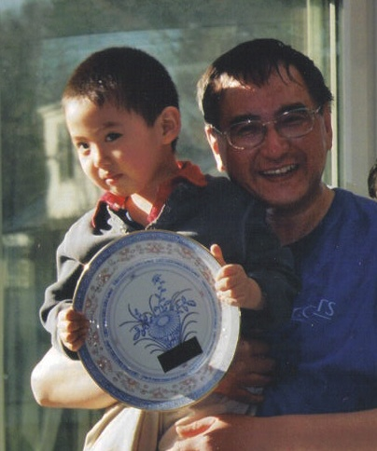
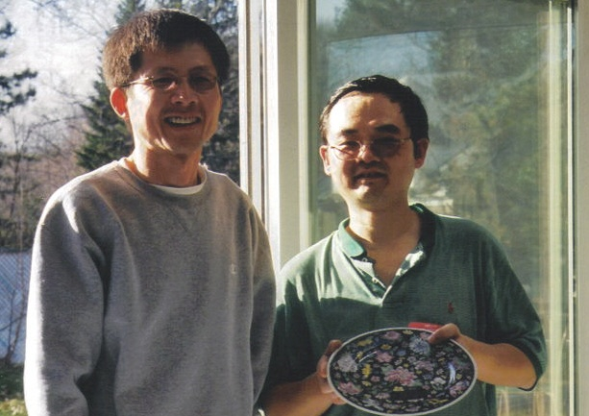
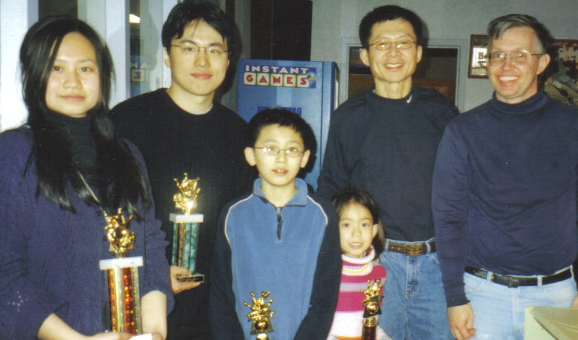

2nd place winner of Table Tennis (with Edwin) Yinrui Yang
Pres Huang with all the Bowling Winners – March 2005
Pres. Huang and 1st place winner of Table Tennis – Weir Gang

RECORD NUMBER AT BOWLING AND PIZZA PARTY
On Saturday afternoon March 12 the snow stopped and the sun peeked through. The result that was a record number of over 40 students and scholars from China (with spouses and children) and American friends participated in the annual Bowling and Pizza Party! Our always-gracious host at Del Lanes in Delmar was Marv Sontz. After some brief bowling instruction everyone completed two games. Next we went to the dining area to enjoy the pizza and soda and learn who would get the trophies. The top male bowler was Yi Sun and the top female bowler was Haiming Yang. The youth bowlers with the best scores were Chen Gong (male) and Suzanna Diehl (female). Our new chapter secretary, Dave Sutor, was given honorable mention for his top one game score of 150; he even had three strikes in a row!

Table Tennis Tournament and Pot Luck - Update
About forty people enjoyed the annual table tennis tournament this year at the Mel Horowitz home. Players ranged from 13 to 70 plus years and over twenty players participated in the elimination matches. In the Semi Final round, Yinrui Yang was able to beat a strong challenge from Andrew Lapinski-Barber and Wei Gang bested a skillful Xiaohang Wang. The top final matches were very close. A volleyball game was held outside for anyone interested in the outdoor activity.
After the tournament, everyone relaxed and enjoyed the varied Chinese and American dishes that had been prepared for the potluck meal. It is rumored that the challengers are already planning next year’s moves and strategies to win.

Upcoming Events
July – Albany Conquest Arena Football game at the Pepsi Arena. Date to be announced soon.
Aug 28 – Welcome Picnic for Students and Scholars from China.

English Conversation Corners
Albany Public Library and RPI
Gene Damm -- "Connecting With America", where recent immigrants practice their English language skills in casual conversation and learn about American culture, happens every Friday from 4:30PM- 6PM. at the Pine Hills Branch of the Albany Public Library located at 517 Western Ave. Contact Xiaofei Li at 482-7911.
Rezsin Adams -- All are welcome to join the English Conversation group (usually) Thursday evenings at the RPI Library in Troy. You can call her to check on the time. 462-0891.

Newsletter Information
Next NL Deadline June 17
We invite you to submit articles for the newsletter to Editor: Ann Parillo, 738 Bobby Court, Niskayuna, NY 12309 or by email at aparillo@nycap.rr.com. Tell us what you want and we will do our best to provide you with more information. Next deadline Jun.15th.

2005 USCPFA
National Friendship Tours
June 18-July 5: A Cultural Kaleidoscope of China--17 days--Est. price $3500--Beijing, Kunming, Dali & Lijiang, Xiamen &
Gulangyu Island, Shanghai--a Friendship Through the Arts tour--Leader: Jill Dye.
September 3-18: Sichuan Spectacular--15 days--Est. price $3095--Beijing, Xian, Chengdu & Jiuzhaigou, Shanghai, including visit to Panda Research Center--Leader: Charles Petersen--information: Barbara Cobb, phone & fax: 615 833-9512, barbara.cobb@juno.com

US-China Peoples Friendship Association
President Kirk Huang
Karol Harlow, Membership
46 Camp Lane
East Berne, NY 12059

May- June 2005 Issue
Place stamp here

Membership Application – Make checks out to USCPFA

Name _____________________________________________________________________

Address _________________________________________________________________

City, State and Zip _____________________________________________

Phone ________________________________________ Circle one of the above

Email _______________________________________________________________________ Amount enclosed ______________________

Mail to: USCPFA c/o Karol Harlow, 46 Camp Lane, East Berne, NY 12059
For More information about membership, contact Karol Harlow at 518-872-2039 or karolow@aol.com.
All memberships include a quarterly copy of the National US-China Review and bimonthly USCPFA Newsletter

Type of Membership
Student -- $15
Senior -- $20
Individual -- $25
Family -- $40

USCPFA National Convention Update
Things are moving along nicely for the convention. As you can see by the Newsletter, the location has been well received by the National Board. The contracts have been signed.
There will be vendor tables at the convention and Allison Stonebly is chairing that along with Nancy Meyers. There is an entertainment committee (Joy Cheung and Allison) and plans are underway to bring some very enjoyable cultural entertainment to events and to the Schenectady Museum Reception on Saturday.
Plans are also underway for short trips after the convention. Being considered are trips to Boston and the Peabody Museum, a trip to New York City and a trip to the Adirondacks. The trips held will depend on the number of people interested in taking these trips. Nancy Meyer, Lucy Wu and Mary Klug are working on designing trips.
Your Help is Needed! There are a number of committees being formed and you will be called upon to lend your hand to help out either before or during the convention. Committees include: Convention Program design, exhibitions, Reception, Registration, and others. Mel will have sign up sheets at various events so you can sign up and you can contact Kirk if you would like to help.

Contact information
President: Kirk Huang 518-782-0746 kkhbravo@yahoo.com
Convention: Mel Horowitz 518-449-8817 edusources@yahoo.com
Programs (convention): Gregg Millett 518-785-0445
gmillett@nycap.rr.com
Programs (monthly): Dan Wilcox dwlcx@earthlink.net

5/15 Richard Mendelson Presents
6/12 Annual Picnics and Meeting
Mailing Information
President Kirk Huang: 9 Hunters Run Boulevard, Cohoes, NY 12047
Membership: Karol Harlow, 46 Camp Lane, East Berne, NY 12059

Support the USCPFA Chapter
Join or Renew Today

