High


II. Gr

US-China Friendship Newsletter
US-China Peoples Friendship Association
Northeast New York Chapter - Albany

May -June 2006 Vol. 32 Issue 3 www.uscpfany.org

We held wonderful events in March and April: Albany River Rats hockey game at Pepsi Arena, fun Bowling and Pizza party at Del Lane Bowling, Table tennis and Potluck party. This year is the election year of our Chapter. The election will be held at the June picnic. I hope you all can attend the picnic having fun and at the same time electing Chapter officers for the next two years.

You are probably aware that the Chinese Community Center (CCC) recently held the opening ceremony for their new building in Latham. A couple of members and I attended the ceremony. We are very happy for CCC that they finally have a building of their own.

For students it is time for finals and then graduations. My best wish for the graduating students.

Have a good spring.

Kirk Huang

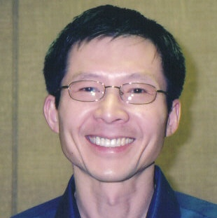
President
Kirk Huang’s
Message

HIKING AT CHRISTMAN SANCTUARY
May 6, Saturday
Join us on an easy one-hour hike at the beautiful Bozenkill waterfalls at Christman Sanctuary near Delansen, NY,and experience one of the Capital region’s little known natural wonders. This peaceful, wooded property was once owned by the poet William Christman and boasts a 30-foot waterfall and a series of smaller waterfalls (all which form the start of the Bozenkill Creek). It is the place that inspired many of the poems of Christman and his son. On this hike you will also enjoy unusual wild flowers and wildlife and a lean-to and rocks (the last two of which hold examples of the poet William Christman and his son’s writings). Cars will be leaving from SUNY and RPI at 2.00 p.m. for the Sanctuary or you can meet at the Sanctuary at 3.00 p.m. We will go directly from the walk to enjoy some local pizza before returning to SUNY and RPI, at approximately 6.00 p.m. This is a family event that will be enjoyed by nature lovers of all ages. As with all Adirondack region hikes to avoid tick or insect bites please make sure your arms and legs are well covered and that you wear hiking boots or sneakers and socks. The Sanctuary is located on Schoharie Turnpike which is a left hand turn on US Route 20 (Western Avenue) approximately 6 miles after the railroad underpass beyond Guilderland, or two miles after the Schenectady County line (going from Albany toward Duanesburg). The parking lot is on the left of Schoharie Turnpike, at the top of the hill, just after crossing the railroad- about 1.6 miles from US Route 20. To confirm your attendance, request a ride or obtain more detailed directions or information call Alison at 461-6331(after 9.00 p.m. or on weekends) or e-mail her at :devonalison1@yahoo.com. Some photos of the waterfall can be found @: www.webshots.com under ‘waterfall at Christman’ or ‘Christman sanctuary.’

NEWSLETTER INFORMATION
Next NL Deadline June. 15
We invite you to submit articles for the newsletter to Editor: Ping Peng, 1572 Dean Street, Niskayuna, NY 12309 or by email at pping2001@hotmail.com. Tell us what you want and we will do our best to provide you with more information. Next deadline June.15th

ANNUAL JUNE PICNIC SET FOR SUNDAY JUNE 4
Our Annual Picnic and Meeting will be held at the Bethlehem Town Park located at Elm Ave, Pavillion A (small pavillion), in Delmar, NY from 12:30 PM to 4:30 PM on Sunday June 4. We invite all members and friends to join the fun and welcome summer. Just in case it rains on our parade we have reserved the pavilion. There will be food, friendship and games! To enhance the food you are asked to bring along a salad, munchies or a desert. At 2:30 PM members will participate in an important decision process as we will be voting on our officers for the next two years and on our revised bylaws. Chapter leaders will also present their annual reports. We do need to know the number attending so that we will have enough food so please contact Mel (phone or email) to let him know.

Capital Region Spring and Summer Activities

Ever Been to China? : Help With Our Survey
We would like to have a record of the number of our members who have been to China. There are many reasons for this. We are often asked questions by people considering travel to China. If we know one or more members who have been to certain cities we can provide better answers. Several members have lived/taught in China. We are often contacted by those who are interested in doing this and would like to have a record of the places and schools/colleges our members are familiar with. If you have ever visited or lived in China (no matter how long or short, how long ago or recent it may have been) please let Mel know (email or phone).

CALL FOR NOMINATIONS : CHAPTER ELECTIONS IN JUNE

Our annual meeting will be held starting at 2:30 PM at the Picnic on Sunday June 4 (see separate article). This is an election year as chapter
officers are elected every other year. Elected positions are: president, vice president, secretary and treasurer. Members are asked to contact
Rezsin Adams (434-8620, pinebush2002@yahoo.com) or Mel Horowitz
(449-8817/melschinafriends@yahoo.com) by May 15 to make a nomination. All members in good standing are urged to participate in this democratic process. Please let us know if you are interested in any of these officer positions.

The Families with Asian Children Cultural Event
On April 1st 2006, the families with Asian children
had a cultural event at Glenmont Elementary School at
which USCPFA had a vendor’s table. It was a wonderful
event which gave the children involved a rich and
diverse experience of Chinese Culture. It included
three performers from our New York State Museum
events: Mary Murphy telling Chinese stories, Helena
Wang ribbon dancing and Alison Stonbely giving a
folded Chinese hat making and decorating workshop.
Mary Chen also organized a delicious lunch, Grace Lin
talked about her wonderful children’s books and there
was Chinese singing and a scavenger hunt and many
other wonderful activities. Our thanks go to Kirk and
Rezsin who manned the table all day and sold many of
our remaining items from the Christmas Bazarre and
Hank and Alison for helping for part of the day.
We also had about 28 little visitors to our table for
face painting, which was great fun!

Steering committee meetings are open to anyone interested and will be held at the Rezsin’s house112 Chestnut street, Albany starting at 6:30 PM on May. 2nd and June. 6th

USCPFA NIGHT AT CONQUEST ARENA FOOTBALL
Saturday - July 22 Pepsi Arena 7:00 PM
Pre-game Block Party 5-6:30 PM

Circle July 22 on your calendar.
That's the official USCPFA night at the exciting Albany Conquest Arena Football game at the Pepsi Arena. We have reserved seats and we'll be recognized on the video scoreboard. We hope that many of our members and friends will be part of this entertaining evening. The game against the Manchester Wolves begins at 7:00 PM. If you have never been to an Arena football game you re in for a treat. Come join the crowd! Our Group tickets are only $10 (the regular price is $18). Tickets must be paid for in advance by sending a check (payable to USCPFA) to Nancy Meyer, 1034 Madison Ave., Troy, NY 12180. You can purchase food there. We are inviting Chinese students and scholars to attend. Donations to help cover some of the cost of these tickets are welcome. If you have any questions call Mel at 449-8817.

Contact information
President: Kirk Huang 518-782-0746 kkhbravo@yahoo.com (9 Hunters Run Blvd, Cohoes, NY 12047)
Events: Mel Horowitz 518-449-8817 melschinafriends@yahoo.com
Programs (monthly): Gene Damm gdamm@nycap.rr.com
Membership – Hank Williams william1@nycap.rr.com (46 Hiawatha Drive, Guilderland, NY 12084)
Nanjing delegation visited our chapter in February. The group enjoyed lunch and conversation with our members at Dragon Buffet. (Picture shown in the next page) Part of the group also went to the home of Yun Li and Ping Peng for traditional Chinese dinner while the others went to the home of Anne Marfey tasting American dinner.
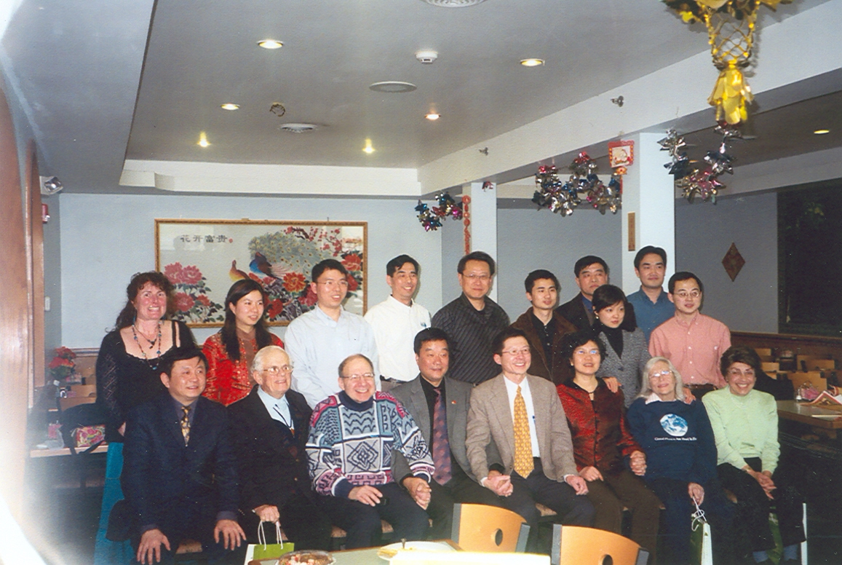
More News and Events
Annual Bowling and Pizza Event
On March 19th 2006, we held our annual bowling and
Pizza event at Del lanes in Delmar. As always we were
very well looked after by the personnel at the bowling
alley who gave a bowling demonstration, set up our
scoring machines and helped us sort out the winners.
This popular event had 13 bowlers and several spectators this year, including past President Lou Speilich who originally helped initiate this event stopped by to support it. This year’s bowling champions were: Songge Liu who was the best female bowler with Jingxia Ni as the female runner up and Quan He who was the best male bowler with Gene Damm as the male runner up. We thank Mel for arranging this fun event for us.

The Opening of the New CCC Building
at Avis Drive.
The weekend of April 7th-April 9th 2006 was very busy for Kirk and several other members of our chapter. In addition to the Ping Pong tournament, and the delegation that visited Albany on Friday, CCC also opened it’s new building at Avis drive on April 8th 2006. It was a wonderful event that was attended by the politicians; James Tedisco, Paul Tonko and Jack McEneny, and had terrific Chinese painting and Chinese cooking demonstrations and dancing events, and many other activities. We thank our treasurer Nancy Meyer, who made on our behalf all the corsages for this event. These corsages were truly beautiful. The CCC thanked Nancy for her corsages and the USCPFA during the event, for our gift of the water fountain. Beyrl Hsia, who gave our cooking demonstration back in
January, also gave one at this event for the CCC.
Beryl will be giving a series of Chinese cooking
classes at the new Avis drive building, details of
which can be found on the CCC web site:
www.cccalbany.org. We congratulate the CCC on the opening of their new building and wish them every success in the future.

The Annual Ping-Pong Tournament
We held our annual ping-pong tournament on April 9th
2006, at the Madison Avenue Baptist church in Albany.
This popular, annual, family event had 22 players in
the tournament and proved to be as exciting and enjoyable as always. There were many close games and great players of all generations and both sexes. The semi finalists and finalists were particularly well-matched and interesting to watch. This year’s winner was Kai Wang, with Xiang Wang as the runner up. After the tournament we enjoyed a potluck dinner and many people continued to play. It was then that Kai’s wife, who is an extremely good player and has won championships in China, joined us. She was very gracious, played several games and let many players test their skills. Thank you Kirk, for your work in arranging this event.

A REMINDER --Check for any last minute changes on our website at www.uscpfany.org.
Quick View Calendar
Date | Event | Location | Time | Page
May. 6 Sat | Hiking | Christman Sanctuary | 3:00 PM | 1
June 4, Sun | Annual Picnic and Meeting | Bethlehem Town Park | 12:30 - 4:30 PM | 1
June 4, Sun | Election | Bethlehem Town Park | 2:30 PM | 2
July 22, Sat | Arena Football | Pepsi Arena | 7:00 PM | 2
May 2 & June 6, Tue | Steering Committee Meeting | 112 Chestnut Street, Albany | 6:30 PM | 2
US-China Peoples Friendship Association
President Kirk Huang
Membership Chair – Hank Williams
46 Hiawatha Drive, Guilderland, NY 12084

May June 2006 Issue
Place stamp here

Membership Application – Make checks out to USCPFA

Name _____________________________________________________________________

Address _________________________________________________________________

City, State and Zip _____________________________________________

Phone ________________________________________ Circle one of the above

Email _______________________________________________________________________ Amount enclosed ______________________

Mail to: USCPFA c/o
Hank Williams, 46 Hiawatha Drive, Guilderland, NY 12084
All memberships include a quarterly copy of the National US-China Review and bimonthly USCPFA Newsletter

Type of Membership
Student -- $15
Senior -- $20
Individual -- $25
Family -- $40

HIKING AT CHRISTMAN SANCTUARY
On May 6

ANNUAL PICNIC AND MEETING
On June 4

