High


II. Gr

US-China Friendship Newsletter
US-China Peoples Friendship Association
Northeast New York Chapter - Albany

January-February 2007 Vol. 33 Issue 1 www.uscpfany.org

Happy New Year! It was an eventful 2006 for our Chapter, which ended with the well-attended and wonderful Holiday Party. The Chapter plans to hold interesting and informative programs in 2007. The tradition programs will be there such as snowshoeing, bowling and pizza party, table tennis tournament, etc. New programs have been planned such as the trip to Peabody Museum in Salem, MA in October, Chinese Culture Day in NYS Museum, etc. Stay tuned!

I look forward to meeting you at upcoming events. May you and your family a healthy and prosperous 2007.

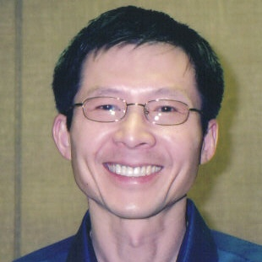
President
Kirk Huang’s
Message

Mao Tsetung and the Cultural Revolution
January 21, Sunday
Xiaoli Zhao, a former visiting professor in Chinese Studies at the University of Albany, will discuss Mao Tsetung and the Chinese Cultural Revolution at the Main Branch of the Albany Public Library on Sunday, January 21st at 2PM.
Zhao will start with a brief review of Jung Chang's critical biography Mao: The Unknown Story and then speak about the tumultuous time in Chinese history called the Cultural Revolution based on her own knowledge and experience. Several Chinese respondents familiar with this period in history will provide questions and comments.

NEWSLETTER INFORMATION
Next NL Deadline February 15
We invite you to submit articles for the newsletter to Editor: Ping Peng, 1572 Dean Street, Niskayuna, NY 12309 or by email at pping2001@hotmail.com. Tell us what you want and we will do our best to provide you with more information.
Next deadline February 15th, 2007

Chinese Cooking Demonstration
January 13, Saturday
On Saturday January 13th at 12.30 p.m. at Westminster Presbyterian church on Chestnut St in Albany (parallel to State St, and two streets down from Lark St, on the left hand side). We are in for a major treat!!! Sheri (Xia) Duan, the renowned singer at the C.C.C. who sang for us at the Convention last year, and is also well known as being an excellent cook, will give a cooking demonstration for us. Sheri will be cooking Fu Rong Shrimp a dish that is beautifully named after the National flower of China, and is meant to resemble and mean, the Hibiscus flower rising out of water (Fu Rong out of Water) and is cooked using the traditional cooking methods of Beijing and Jiangsu The colorful embellishment is gorgeous and the taste is scrumptious!! After the demonstration we will share a potluck lunch and sample Sheri’s cooking. Please call Alison @ 518 461-6331 after 6p.m. or on weekends to confirm your attendance or e-mail her @ devonalison1@yahoo.com . We hope to see you there!

* Do you have an email address? Send it to Mel if you'd like to be added to our "USCPFA Update" service to obtain program information and reminders *

Movie! Movie!
February 10, Saturday
On February 10th, 2007 (Saturday) 12:30 PM, “Farewell My Concubine” will be shown at Bethlehem Library (451 Delaware Ave, Delmar). Academy Award-nominated, this film earned the Golden Globe as best foreign film in addition to claiming Best Picture honors at the prestigious Cannes Film Festival! It’s the compelling tale of two lifelong friends unexpectedly caught in a passionate love triangle with the woman who comes between them! Featuring Gong Li (Miami Vice, Memoir of A Geisha), Directed by Chen Kaige, Runtime: 172 minutes, Chinese with English subtitles. Contact: Kirk 7820746. Light refreshment will be provided.

More News

WINTER FUN! SNOWSHOEING/NATURE/LUNCH
FEBRUARY 24
On Saturday February 24 we will go SNOWSHOEING at the Five Rivers Environmental Education Center. This an annual event for our members, students and scholars from China and includes children who are at least 8 years old. You will need to arrive by 9:45 AM. We should finish at the center by about 11:30 AM. This center is located on Game Farm Road in Delmar, which is a right hand turn if you are headed south on Route 443/Delaware Ave (beyond the Bethlehem High School). Then we will go back towards Albany about two miles to the Delmar Reformed Church (386 Delaware Ave./Rte 443) to get warm, enjoy a lunch and great conversation.
When we begin the guides at the center will explain how animals survive in the winter. Then we will go for a walk using snowshoes (they provide them but if you have your own, please bring them) to walk on top of the snow. Let's hope we actually have snow-but we'll have a walk even if there is none. They will show us animal prints and habitats. Be sure to dress warm. For Winter Outdoor activities you usually need a coat, hat, mittens, warm pants (snow pants if possible). Dress in layers.
SPACE IS LIMITED so we ask you to call and make your reservation. Reservation contacts are: Kirk (782-0746), Mel (449-8817). Please contact us if you need a ride or have space in your car so that you can offer a ride, need more directions or have any questions.

HELP US TO PLAN FOR THIS YEAR’S ANNUAL BANQUET
We are now planning our 2007 Annual Banquet (to be held in late April or early May) and we need your help. Each year we present awards and include Chinese and American entertainment. We encourage you to make nominations for the Friendship Links Award. This award goes to the area individual or organization that is NOT a USCPFA member and has done the most to promote US-China Friendship. We also would like suggestions or volunteers for entertainers. Performers will have about ten minutes each. Please contact Mel (449-8817) with this information as soon as possible. The deadline is the end of February

Congratulations to Rezsin Adams
Congratulations to Rezsin Adams, who was recently chosen one of three recipients of The James Perry Awards for Progress Leadership. This annual award is given to an individual who has demonstrated outstanding Citizen Action in the Capital District. Rezsin, we thank you and want you to know we all appreciate your leadership, dedication and service to our community.

Contact information
President: Kirk Huang 518-782-0746 kkhbravo@yahoo.com (9 Hunters Run Blvd, Cohoes, NY 12047)
Events: Mel Horowitz 518-449-8817 melschinafriends@yahoo.com
Programs (monthly): Gene Damm gdamm@nycap.rr.com Phone: 518-482-7675
Membership – Hank Williams 518-456-6886, williams1@nycap.rr.com (46 Hiawatha Drive, Guilderland, NY 12084)

Steering Committee meetings are open to anyone interested on Jan. 3^{tth} (6:30 PM at Albany Public Library, Washington Ave and Feb. 6th (7PM at 112 Chestnut St. Albany).

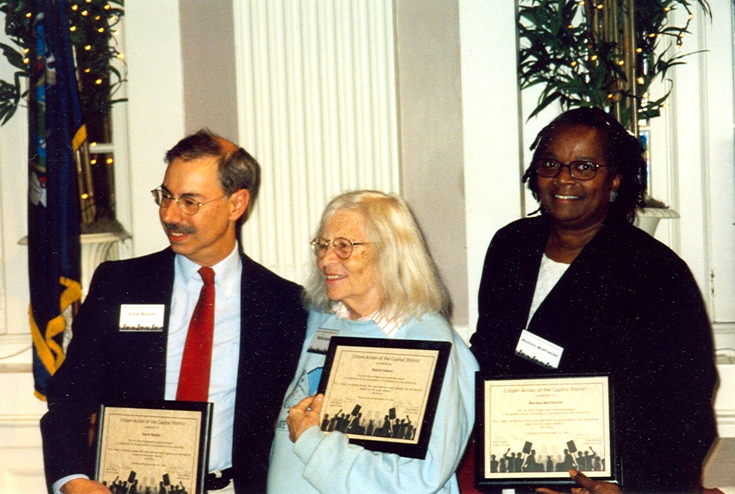

Looking Ahead
On Sunday, March 18th, Alvin Magid, Professor Emeritus of Political Science at Rockefeller College, University at Albany will discuss his forthcoming book "How Angry Is Heaven? A Shanghai Journal in the Time of Tiananmen." Dr. Magid taught at Fudan University, Shanghai in 1989, 1991, and 1992. This program will begin at 2PM at the Main Branch of the Albany Public Library.
Our Annual Bowling Tournament/Pizza Party will also be held in March. Our Annual Table Tennis Tournament and Pot Luck Dinner will be held in early April.

Culture Corner
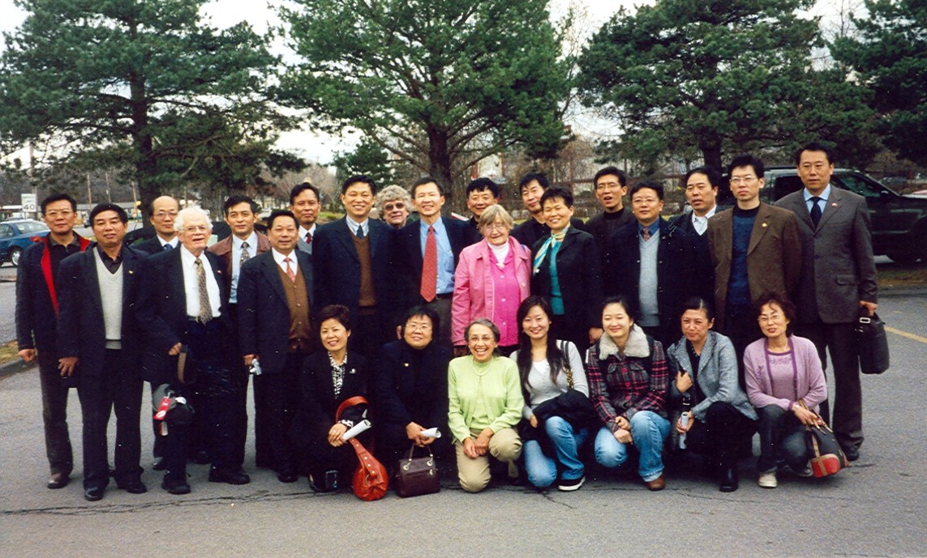
CTUS group from Jiangsu Province
On November 16 and 17, Our Chapter hosted a CTUS group of 20 Planning delegates From Jiangsu Province. Thursday evening, they were welcomed into the homes of several members for an American dinner. Friday, they attended presentations at the Albany Public Library by Mr. George Robbins, Director of Graduate/Foreign Admissions at RPI in Troy, and Attorney Paul Bray, City Planning Expert, Newspaper Columnist and President of Roundtable Civic Forum. The presentations proved to be an informative learning experience for all.

Letter from our Chapter member Irene Ho.
Below picture was taken on Nov 16, 2006. My father was the president of Jinan University in China from 1935 to 1946. He led the university to relocate from the Japanese-occupied Shanghai to the rural area in the southeast Chinese province of Fujian, where the university remained the only institution of higher education with a successful operation in the Chinese-controlled regions in eastern China until the end of the World War II. This year marks the centennial of Jinan University. They newly built six statures in bronze in memory of those people who made the greatest contribution. In the picture I was unveiling my father's stature with the current president (Photographed by Zhuang Jin)
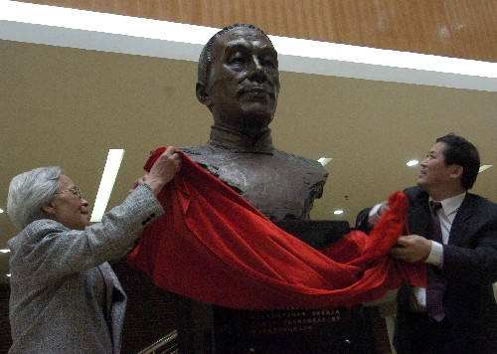

A REMINDER --Check for any last minute changes on our website at www.uscpfany.org.

CELEBRATE! THE YEAR 4703 BEGINS
ON FEBRUARY 18. IT IS THE
YEAR OF THE PIG.
Celebrate the Chinese New Year/Spring Festival! In China this is a fifteen-day event. The Spring Festival is the most important festival for the Chinese people and is when all family members get together, just like Christmas in the West. Days before the New Year, every family is busy giving their house a thorough cleaning, hoping to sweep away all the ill-fortune there may have been in the family to make way for the wishful in-coming good luck. People also give their doors and window-panes a new paint, usually in red color. They decorate the doors and windows with paper-cuts and poems called couplets which are supposed to bring luck in the form of "happiness", "wealth", and "longevity". Paintings of the same theme are put up in the house on top of the newly mounted wall paper.
An RPI email states its importance this way. "As the new year's day of the Chinese lunar calendar, spring festival is especially important for students abroad. So the goal of this party is to make everyone enjoy the festival here thousands of miles away from home". We know of two parties that will be held. RPI CSSA will hold their SPRING FESTIVAL PARTY on Saturday Feb 17th at RPI. The annual CCC Celebration will be held on Sunday February 18 at The Egg Theater. Details of these cultural events will be sent out by email to those on the USCPFA Update email list. To be added to the lists simply send Mel an email request.

Improve Your English Conversation
USCPFA members meet with our friends from China to help them improve their English. Rezsin meets with Chinese students and family members at RPI in Troy for English Conversation one afternoon and one evening a week. Lloyd will meet with University at Albany students and family members one evening a week at his home near the University. Those interested please call Rezsin 462-0891 or Lloyd at 438-1924.

Quick View Calendar
Date | Event | Location | Time | Page
Jan 13, Sat | Cooking Demonstration | Westminster Presbyterian Church | 12:30PM | 1
Jan 21, Sun | Seminar on Chinese Cultural Revolution | Albany Public Library | 2:00 PM | 1
Feb 10, Sat | Movie | Bethlehem Library | 12:30 PM | 1
Feb 24, Sat | Snow Shoeing | Five Rivers Environmental Education Center | 9:45AM | 2
US-China Peoples Friendship Association
President Kirk Huang
Membership Chair – Hank Williams
46 Hiawatha Drive, Guilderland, NY 12084

January February 2007 Issue
Place stamp here

Membership Application – Make checks out to USCPFA

Name _____________________________________________________________________

Address _________________________________________________________________

City, State and Zip _____________________________________________

Phone ________________________________________ Circle one of the above

Email _______________________________________________________________________ Amount enclosed ______________________

Mail to: USCPFA c/o
Hank Williams, 46 Hiawatha Drive, Guilderland, NY 12084. Email: williams1@nycap.rr.com
All memberships include a quarterly copy of the National US-China Review and bimonthly USCPFA Newsletter

Type of Membership
Student -- $15
Senior -- $20
Individual -- $25
Family -- $40

Coming Soon:
Cooking Demonstration
Jan. 13
Seminar on Chinese Cultural Revolution
Jan. 21

