
High

US-China Friendship Newsletter
US-China Peoples Friendship Association
Northeast New York Chapter – Albany
www.uscpfany.org

www.uscpfany.org II. Gr
May-June 2008 Vol. 34 Issue 3

We held wonderful events in March and April: fun and well-attended Bowling and Pizza party, Table tennis and Potluck party, speakers talking about their personal experiences of adopting children from China and, of course, the ever so popular Annual Banquet. This year is the election year of our Chapter. The election will be held at the June picnic. I hope you will attend the picnic having fun and at the same time electing Chapter officers for the next two years.

Good luck to the students who are taking the final exams. My best wish to the graduating students on their future endeavors.
Kirk
President
Kirk Huang’s
Message
ANNUAL JUNE PICNIC, SUNDAY JUNE 15
Our Annual Picnic and Meeting will be held at the Bethlehem Town Park located at Elm Ave, Pavillion A (small pavillion), in Delmar, NY from 12:30 PM to 4:30 PM on Sunday June 15. We invite all members and friends to join the fun and welcome summer. Just in case it rains on our parade we have reserved the pavilion. There will be food, friendship and games! To enhance the food you are asked to bring along a salad, munchies or a desert. At 3 PM members will participate in an important meeting as we will be voting on our officers for the next two years. We do need to know the number attending so that we will have enough food so please let Mel or Kirk know (phone or email) that you will attend. Please also let us know if you need ride.

MAY AND JUNE PROGRAMS SET
Our monthly program for May will be "The History of the Peking Man Digs of the 1920's- an Example of East-West Cooperation" presented by Peter L. Huston of Cornell University. The program at the Sanford Colonie Library on Sunday, May 18th will begin at 2 PM. The library is located at 629 Albany-Shaker Rd.
Our program on Sunday, June 1st at the Guilderland Public Library at 2PM. will be "A Peek behind the Bamboo Curtain of Chinese Business" presented by Prof. Paul Miesing of the University at Albany business school.
Prof. Miesing was a Fulbright lecturer at Fudan University in Shanghai. Among his research interests is strategic change in China and India.
Guilderland Library is located on the left, off Rte.
#20, a few miles west of Rte. 155.

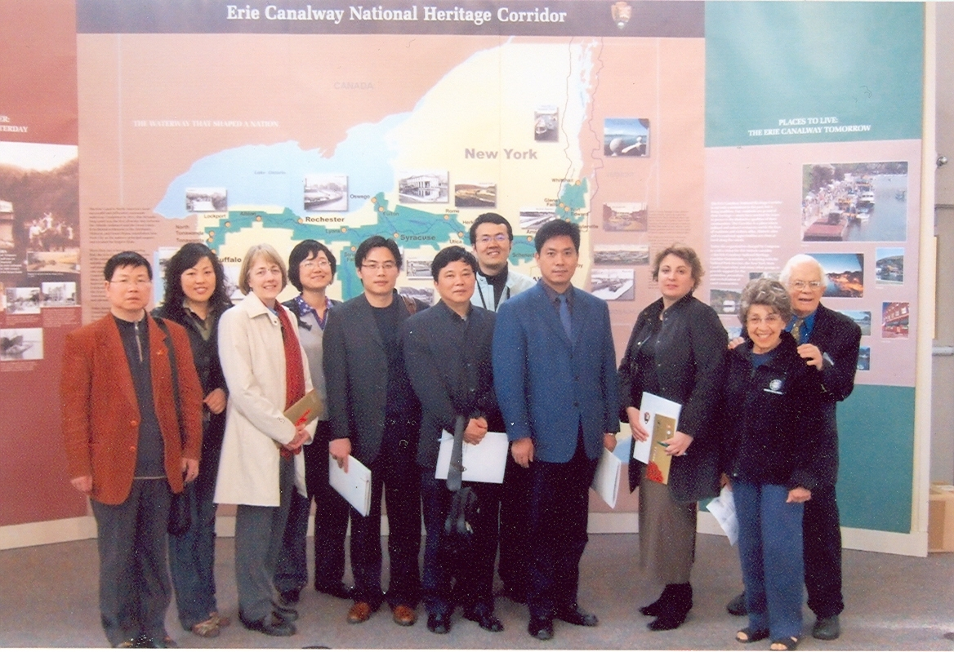

CTUS GROUP
Tuesday, April 1, 2008, USPFA hosted a group of 7 delegates from The Waterway Bureau of Jiangsu Provincial Communication Department. They were met at Albany International Airport by members Kirk Huang, Gene Damm, Bea and Bob Swire and Nancy Meyer. Honorary certificates and USCPFA Friendship pins were presented to delegates by President Kirk Huang at The Dragon Buffet luncheon. The delegates then proceeded to Peebles Island in Cohoes, where an in-depth
(To be continued on page 3)
Delegation from the Waterway Bureau of Jiangsu Provincial Communication Department.

More Events
RPI STUDENT FROM CHINA INSPIRES NINGXIA PROJECT
I've just returned from China as part of a four member Rotary Team in preparation for sponsoring a Pure Waters Project in the desert area of Ningxia Hui Autonomous Region (near Inner Mongolia). It began at a June, 2007 meeting with Chinese Scholar Lining He and his parents. After long planning, Rotary funded this site visit to the project area. I had known Lining, an RPI Doctoral Student, for several years through the USCPFA's programs for our local students/scholars from China.
I had been on three previous visits to China since 1977. This was my first visit to an area in Western China. As before, the most impressive aspect of our visit was the warm, friendly people that we met. Compared with the more modern, developing eastern coastal cities of China, this was a different China. The cities are smaller, the roads often mini-roller coaster rides and the rural areas are in often quite needy. This is a desert region. The Chinese government is helping to develop these areas but, as the recently issued May National Geographic edition about China documents, developing China has several problems to contend with.
One problem is water. Maerzhuang, a collection of three relatively remote villages, is the focus of our Pure Waters Project. The water will come from the Huang He or Yellow River. This river is in trouble as a result of industrial emissions and waste due to leakage. The government is constructing a leak free pipeline to a reservoir and filtration plant near these villages. The Rotary project (helped by the USCPFA, Ningxia Charity Federation and Youxie) will bring the pipeline to all families to Maerzhuang.
After visiting the area and meeting the villagers and project leaders we feel encouraged that this is a worthwhile project for water conservation and to improve the health and raise the standard of living for poor villagers. Now we need to raise approximately $30,000 to be used to provide the tools and materials for the project. The villagers themselves, guided by the project engineers, will provide the labor. While much of the funding will come from Rotary, individual donations are needed. Visit our team web site and blog for details and photos of our journey and pledge letters for donors. http://groups.google.com/group/china-water-projects for project basics and
http://chinawaterprojects.blogspot.com/ to follow the progress on our journey. We are still blogging. All donations are tax deductible.

(To be continued)
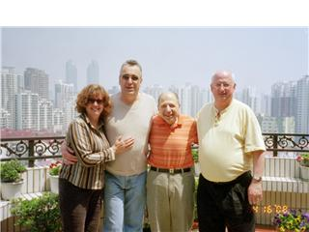

ANNUAL BANQUET A BIG SUCCESS!
On Thursday evening about 85 USCPFA members, friends and students from China filled Central Avenue's Dragon Buffet with the sounds of friendship. A lot of effort by Kirk, Alison, Nancy, Rezsin, Mel and others went into putting together this awesome event. After satisfying our taste buds with the vast variety of delicious Chinese, American and other pungent dishes, we settled down to the celebration. We began by celebrating our award winners: Anne Marfey our favorite hostess received the Friendship Builder Award, Xiaofei Li who has built the Albany Public Library's Chinese Book Collection and leads the library's Asian Study Group received the Friendship Links Award and Caitlin Mahar top Chinese Language and Culture student of Maple Hill High School's innovative teacher Mark Hoyt received the Tema Bellinson Memorial Award. Kirk also presented the CCC with a donation from the USCPFA and Rezsin presided over the annual raffle of some very special gifts from China.
Now it was time for the entertainment. This year we had a unique variety of Chinese and American performers. First Dan Wilcox read from his unique Portray, most of which was inspired during his China visit while his daughter was teaching there. This was followed by Bob Baum who demonstrated why he was not a famous Catkill resort comedian (we did, however, have a few good laughs) and treated us to an all too brief musical delight on the ukulele and trumpet. A real treat was the beautiful Chinese ballad sung by Jolin Huang who has sung for us on other occasions, including at the NYS Museum.
We thank everyone who planned this event, attended and/or preformed. If you missed it, be sure to attend next year.

Culture Corner

Contact information
President: Kirk Huang 518-782-0746 kkhbravo@yahoo.com (9 Hunters Run Blvd, Cohoes, NY 12047)
Vice President: Bob Swire 518 -399-7356
Treasurer: Nancy Meyer 518-271-6343 nancearb@peoplepc.com
Secretary: Alison Stonbely 518-461-6331 devonalison1@yahoo.com
Events: Mel Horowitz 518-449-8817 melschinafriends@yahoo.com
Programs (monthly): Gene Damm gdamm@nycap.rr.com Phone: 518-482-7675
Membership – Hank Williams 518-456-6886, williams1@nycap.rr.com (46 Hiawatha Drive, Guilderland, NY 12084)

Bowling and Pizza Party
Sunday, March 16, 2008, we held our annual Bowling and Pizza Party at Del Lanes, Delmar. 16 students and 7 members bowled in the tournament. Competition was fierce. Prizes were awarded for total highest scores for male and female, and highest score in a game, male and female. Winners were: Xin Li and Joyce Baum for the highest overall scores and Wei and Xia Li for highest score in a game. Since we began this event, many years ago, Lou Spelich, one of our past Presidents of USCPFA, has been instrumental in obtaining Del Lanes for this event each year. This year, Lou was presented with a Special Commemorative Trophy Pin containing everyone’s signature, by co-owner of Del Lanes, Marvin Sontz.

(Continued from page 1)
presentation of The Erie Canal National Heritage Corridor was given by Lori Duell, Project Manager and Jean Mackay, Director of Commission and Outreach of The National Park Service. The group then went to see the Waterford Lock of the Erie Canal. Although the lock system does not officially open until May, the delegation was able to see a barge and one of the larger commercial transport boats that were anchored inside the lock; and to understand the importance that the barge plays in guiding the larger transport through the canal system.
The USCPFA Table Tennis Tournament and Pot Luck Dinner, April 6th 2008, at the Chinese Community Center
Our Annual Table Tennis Tournament and pot luck dinner at the CCC was, as always, great fun and well attended. Last Year’s Champion Marius Agrotes came back to defend his title. The semi finals and Finals were very exciting! Marius and Pengyu Han individually defeated a Chinese couple in the semi finals. Pengyu gave Marius some tough opposition in the final games; but Marius won the tournament for the second year in a row! Congratulations to Marius. If you know any good table tennis players, make sure you bring them to next year’s tournament. Delicious food, good conversations and friendship followed at the pot luck dinner. There was so much fun that everyone stayed well past the scheduled end time.

News
Palm Beach County Chapter is organizing a Super Cultural and Educational Tour June 14-27, visiting Beijing, Yichang, Three Gorges Cruise, Chongqing, Guilin, Suzhou and Shanghai. For more information please call Joy Dupont at 516-844-3882.
Are you interested in teaching Conversational English for one month this summer in Sichuan Province? All expenses paid. Please call 462-0891 for more information.
NEWSLETTER INFORMATION
Next NL Deadline June 15
We invite you to submit articles for the newsletter to Editor Ping Peng, 1572 Dean Street, Niskayuna, NY 12309 or email at pping2001@hotmail.com. Tell us what you want and we will do our best to provide you with more information. Next deadline: June 15th, 2008.
* Do you have an email address? Send it to Mel if you'd like to be added to our "USCPFA Update" service to obtain program information and reminders
A REMINDER --Check for any last minute changes on our website at www.uscpfany.org.

Steering Committee meetings are open to anyone interested on May 15^{h} and June 12th 7:00 PM at 112 Chestnut St. Albany.

Quick View Calendar
Date | Event | Location | Time | Page
Sun, May 18 | The Story of Peking Man | Sanford Colonie Library | 2:00PM | 1
Sun, June 1 | Seminar on Chinese Business | Guilderland Public Library | 2:00 PM | 1
Sun, June 15 | Annual Picnic | Bethlehem Town Park | 12:30PM – 4:30PM | 1
Membership Application – Make checks out to USCPFA

Name _____________________________________________________________________

Address _________________________________________________________________

City, State and Zip _____________________________________________

Phone ________________________________________ Circle one of the above

Email _______________________________________________________________________ Amount enclosed* ______________________

Mail to: USCPFA c/o
Hank Williams, 46 Hiawatha Drive, Guilderland, NY 12084. Email: williams1@nycap.rr.com
All memberships include a quarterly copy of the National US-China Review and bimonthly USCPFA Newsletter * Donations are Tax Deductible to extent allowed by law.

US-China Peoples Friendship Association
President - Kirk Huang
Membership Chair – Hank Williams
46 Hiawatha Drive, Guilderland, NY 12084

May –June 2008 Issue

Place stamp here

Type of Membership
Student -- $10
Senior -- $20
Individual -- $25
Family -- $40

Coming Soon:
Exciting Programs on
May 18 and June 1
Annual Picnic
June 15

