

US-China Friendship Newsletter
US-China Peoples Friendship Association
Northeast New York Chapter – Albany
www.uscpfany.org

d High

=www.uscpfany.org II. Gr
May – June – July 2014 Vol.8 Issue 3

President's Message

We held many wonderful events in March and April. This year’s Banquet was another successful one; particularly the beautiful entertainment performances by talented performers. I like to thank all who volunteered, helped and attended to make this a successful event.

This is the election year for our Chapter. The election will be held at the June picnic on Sunday June 15. Please join the picnic, having fun and electing Chapter Officers for the next two years.
I would like to wish all graduating students best of luck on their future endeavors. I wish you all have a very good summer!

Kirk
Kirk Huang
President USCPFA

* Do you have an email address? Send it to Mel if you'd like to be added to our "USCPFA Update" information and reminders

Springtime Outing
Huyck Preserve and Biological Research Station – Saturday May 31

Join us on a hike about 40 minutes from Albany in a very scenic area located in the picturesque village of Rensselaerville on Saturday, May 31, 2014. Hiking is a very popular activity and we are looking forward to sharing this experience again with members, students and scholars from China.
View the spectacular waterfalls and pristine lake in the splendor of the Helderberg Mountains. We will take 2 separate hikes. One hike is a total distance of 1 mile round trip and will take us along a trail to the upper bridge at the top of the Rensselaerville Falls.
After completing this hike we will take a short drive along the shore of lake Myosotis to a level hike along Lincoln Pond, a total distance of 0.6 miles. You might see birds and other wildlife along this hike.

We suggest you bring a bottle of water and wear comfortable hiking shoes. Sneakers are fine!

We’ll meet at SUNY Collin Circle at 1 PM. Please call Bea or Bob Swire at (518)399-7356 to let us know if you are taking the hike--if you need a ride--or if you can provide rides. We request that you leave a telephone number in case bad weather is predicated for this day. Please-NO E-MAILS! We are looking forward to meeting you.

BRING A CAMERA!

A REMINDER — Check for any last minute changes on our website at www.uscpfany.org

Events
held for many years at Sissy and Mel Horowitz house, has always been a lot of fun!
To say that this year’s championship game was the most exciting ever would be an understatement! The other players and attendees were all speechless and almost gripping their seats and holding their breath with excitement, as they watched this year’s final. The two finalists were almost perfectly matched. Close game after close game, before it was won! Joe Ogilvie, an American friend of the Baums, who was once a professional player, eventually won the Championship. The runner up was Bo Fang, a Chinese graduate student from SUNY. Joe’s three children quietly sat on the sidelines, in support of their dad. The Championship could have gone either way, but in the end with experience and professionalism under his belt, Joe narrowly won the final game by 28 to 26.
Afterwards a delicious range of dishes at our pot luck dinner was enjoyed by all, with friendship and laughter. We also met for the first time Momoka, our youngest member and the adorable one month old daughter, of our members, Hiro and Yuki. It really was a wonderful afternoon in every way!

ANNUAL BANQUET: HONOR, FEAST, FRIENDSHP and ENTERTAINMENT
Our annual banquet was held at the Capital Buffet on Saturday April 12, 2014 with members 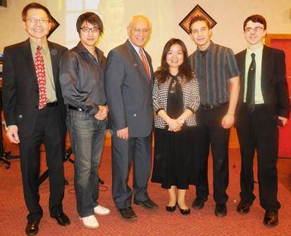
and friendships were warm and cheerful.
This year’s awards went to three very deserving people and community organization. The Friendship Builder Award was presented to long time member Dr. Gregg Millett by Kirk. Those who attended the 2005 National USCPFA Convention in Schenectady will remember the important role
Annual June Picnic and Election
Sunday June15 @ 12 PM
Our Annual Picnic and Business Meeting will be held at the Bethlehem Town Park located at Elm Ave, Pavillion A (small Pavillion), in Delmar, NY from 12:00 PM to 4:30 PM on Sunday June 15. We invite all members and friends to join the fun and welcome summer. Just in case it rains, we have reserved the pavilion. There will be food, friendship and games! USCPFA will provide hot dogs, buns and soda. To enhance the food, you are asked to bring a dish to share. Around 2:30 PM, members will participate in business meeting as we will be voting for Chapter Officers for the next two years. We do need to know the number attending so that we will have enough food. So please let Kirk know that you will attend kkhbravo1@yahoo.com Please also let him knows if you need a ride or can provide rides.
Bowling and Pizza Party

On March 15, the USCPFA held its annual bowling and pizza party at Del Lane. The affair was well attended and everyone enjoyed the entertaining and fun filled event. After bowling, we enjoyed fresh pizza, cookies and good conversation. Trophies were awarded for the highest male bowler, Gene Damm, and the highest female bowler, Joyce Baum. We are grateful to Lou Spellich for starting this activity some years ago and were delighted that he and his wife Jane were able to join us and share in 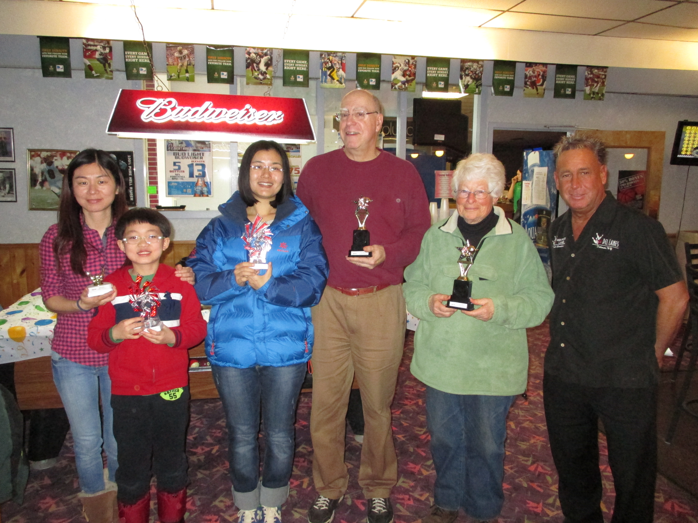

Table Tennis Tournament
As usual we had a good turnout for this year’s table tennis tournament and pot luck dinner on April 6, 2014. This event, which was

and friends enjoying this annual event. As usual we feasted on the vast array of great Chinese and other tasty dishes and the conversation
the festivities. Thanks to all who attended and Del Lanes which made this event a big success.

Events
A REMINDER --Check for any last minute changes on our website at www.uscpfany.org
used as an herbal medicine at first. Its refreshing effect made it a favorite drink later on. It can be classified by procedure, quality, preparation methods, and so on. Here it is classified by the method of processing.
Green Teas are the most popular in China. Fresh tea leaves are baked. They are not fermented during processing, and thus retain the original color of the tea leaves. The most famous green tea is the Dragon Well tea, grown in the hillsides of Hanghou. Generally, water temperature of 85 Celsius degree is the best. The water is clear and the leaves remain green.
Black teas, also known as "red tea", are fermented teas. Unlike green teas, they don't lose their fragrance easily.
Oolong teas are partially fermented, resulting in a black-green tea. Tieguanyin has become the representative of oolong tea although the most precious is Dahongpao (Big red robe).
White teas are made from immature tea leaves, that are still covered with a downy, silvery fuzz.
Scented teas are made by mixing various flowers and petals with green or oolong teas. The best known among these is jasmine tea.
Yellow tea usually implies a special tea processed similarly to green tea, but with a slower drying phase, where the damp tea leaves are allowed to sit and yellow.
Brick Tea is compressed into the shape of brick. It is very popular among the Tibetan, Mongolian and Uighur for making yak butter tea or milk tea.
. 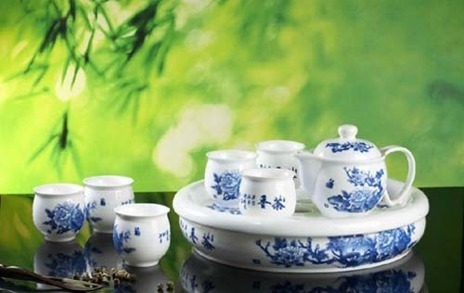
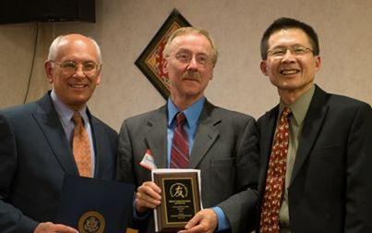

to his father’s WWII photos of Kunming, China. The Friendship Links Award was presented to the William Sanford Town Library (Colonie Library) by Kirk. With their excellent facilities we have held many of our successful programs there and they have many resources to help us understand China, including films from and about China. The Tema Bellison Memorial Scholarship was presented Tech Valley High School Senior Elizabeth (Libby) Cass by Mel Horowitz as her teacher Sophia Tien-Hui Hsia and family looked on proudly. Honorable guest Congressman Paul Tonko presented certificates to the honorees. Other guests attending were Matthew Peter, Chief of Staff of Albany Mayor and Diana Bennett, Congressman's Constituent Representative.
Between the entertainment many raffle prizes were drawn. Tristen Jarvis and Lucas Richard, a string bass duo, favored us with some classical and pop compositions. This was followed by Daisy Lin playing the keyboard with her charming original melodies. To round out the super musical treats Lily Dong played the Chinese Zither wonderfully and Li Fu belted out some Chinese tunes. Of course Kirk followed up with our new tradition: a singing President!
It was, as usual, a great evening!

Chinese Tea Classification
Chinese people are believed to have enjoyed tea drinking for more than 4,000 years. Tea was
Contact information
President: Kirk Huang 518-782-0746 kkhbravo@yahoo.com (9 Hunters Run Blvd, Cohoes, NY 12047)
Vice President: Bea Swire 518 -399-7356
Treasurer: Nancy Meyer 518-271-6343 nancearb@gmail.com
Secretary: Alison Stonbely 518-944-1614 devonalison1@yahoo.com
Event Updates: Mel Horowitz 518-449-8817 melschinafriends@yahoo.com
Membership: Lorraine Okeson 518-237-7173 lorraine.okeson@gmail.com
Gregg played on the Convention Committee. Gregg has also presented some fascinating programs for us, mainly connected
Pu erh has come into vogue among white-collar workers in major cities owing to its unique earthy mellowness.

Quick View Calendar
Date | Event | Location | Time | Page
Sat May 31 | Springtime Outing at Huyck Preserve and Biological Research Station | Meet at SUNY Collin Circle | 1 PM | 1
Sun June 15 | Annual June Picnic and Election | Pavillion A  Bethlehem Town Park  Elm Ave, Delmar, NY | 12PM-4:30 PM | 2

Quick View Calendar

Membership Application – Make checks out to USCPFA

Name ____________________________________________________

Address __________________________________________________

City, State and Zip __________________________________________

Phone ____________________________________________________

Email ____________________________________________________ Circle one of the above

Amount enclosed* ______________________

Mail to: USCPFA c/o Lorraine Okeson, 10 Watervliet Ave, Cohoes, NY 12047
All memberships include a quarterly copy of the National US-China Review and bimonthly USCPFA Newsletter
* Donations are Tax Deductible to extent allowed by law.

US-China Peoples Friendship Association
President - Kirk Huang

May – June – July 2014 Vol.8 Issue 3

Place stamp here

Type of Membership

Student -- $10
Senior -- $20
Individual -- $25
Family -- $40

