

US-China Friendship Newsletter
US-China Peoples Friendship Association
Northeast New York Chapter – Albany
www.uscpfany.org

d High

Nov - Dec 2016 Vol.10 Issue 5

President's Message

It has been a nice fall season. Weather has been mild, and it was complemented by leaves with beautiful colors.

2016 has been another successful year for our Chapter! Many events were held with good attendance and wonderful time. The 2017 events will be sure equally successful.

Holiday Season is a joyful time to get together with family and friends. I wish you and your loved ones a very happy and joyful holiday season! I look forward to seeing you at our Holiday Party on December 16 and at our Chapter’s 2017 events.

Kirk
Kirk Huang
President USCPFA

* Do you have an email address? Send it to Mel if you'd like to be added to our "USCPFA Update" information and reminders


HOLIDAY PARTY – Friday December 16th

Our Annual Holiday Party will take place on Friday, December 16th from 6 PM to 9 PM at Friends Meeting House, 727 Madison Ave, Albany. We'll start with potluck. Everyone please bring a dish to share. We'll sing, tell stories, and have fun. All are welcome. Please let Kirk kkhbravo1@yahoo.com know that you are attending, and if you need a ride, or you can provide rides. See you at the Party!

The Book Tour Of Paul Trescott’s “From Frenzy To Friendship: The history of US- China Peoples Friendship Association"

On August 20th 2016, Paul and Kittie Trescott came to Colonie Library on their US book tour of Paul Trescott’s book "From Frenzy to Friendship". Paul outlined the main points of the book. Initially in 1971, USCPFA, which now has as part of their mission statement, that the Friendship does not include politics, was a very political organization, and on both Chinese and US sides was very much about Communism. Many of the founding members were radicals, who were interested in the ideals of communism. China’s interest at that time was encouraging these radicals who were interested in Communism. USCPFA was the only organization back then that was able to bring US citizens on tours to China and the tour business was very lucrative in these early days. Many of its members were very much on the left side of politics and many of its activities were investigated by the FBI. After
A REMINDER — Check for any last minute changes on our website at www.uscpfany.org
Deng Xiaoping opened China to western world, USCPFA went from being an organization that had paid employees organizing their tours, to being one of many that offered tours to China. Paul Trescott’s book is very interesting as it clearly shows the growth and development of the Association from its early political days to today.

Welcome Picnic

On Saturday August 27th, 40 USCPFA member, Chinese visiting scholars and their children gather together at Elm Ave Town Park for welcome picnic to kick off the beginning of new school year. The weather was sunny and the grass was green. We enjoyed the potluck lunch with the delicious food everyone brought, along with just-cooked hot dogs, good conversations and good company. After lunch, we gather under the pavilion introducing ourselves and getting to know each other. Kirk also announced the planned fall events. Everyone all showed strong interests in attending future events. Some people took a short hike at the Park while others continued good conversation and getting to know each other better. It was a well-attended and enjoyable event for everyone.

September Hiking

On Saturday September 24th, a beautiful sunny day, a group of 30 USCPFA members and Chinese visiting scholars took a hiking at Vroman’s nose in Schoharie County. The hiking distance was not long but it was steep at times. it was a test for everyone cardiac capacity. It was all worth it when we climb to the top. The entire beautiful view of Schoharie Valley was under our feet. Everyone was busy taking photos of the lovely scenery. Then we all sat down having lunch along with good conversations while viewing the beautiful scenery. After lunch, we went down the mountain and headed to Barber’s Farm.

We all impressed by the freshness of the vegetables which were grown right at the Farm and bought some of them home. We then went sightseeing at Vroman’s house and the cover bridge. We all had a wonderful time!

Professor He's exhibition and presentation of his work "Face to Face"

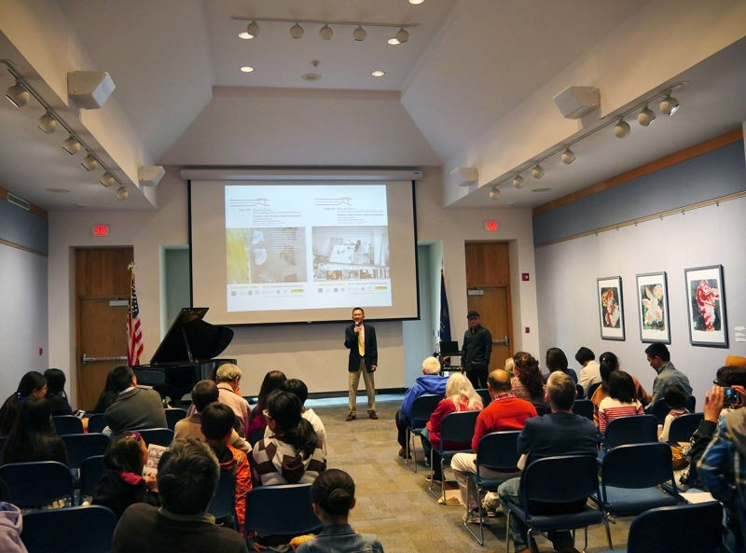

On Saturday October 8th 2016 at Guilderland Library, Professor He Sien, Assistant Dean of Academy of Fine Arts, Chengdu Normal University, led a program with an exhibition of his art work, videos interviews, ideas and communication called "Face to Face." This Program was sponsored by our Chapter and the Confucius Institute at SUNY Albany.
Professor He is an accomplished artist, who has shown his work all over China, Belgium, Italy, America, India, and other countries in the world and has done fellowships in several of these countries. Professor He showed several videos of his art work in different countries. The videos of his Beijing opera masks and His fellowship in India are two excellent videos showing an artist in the process of making abstract art. They clearly show his focus and intention in his work.
Professor He's passion, both in his own work

Events

Events
A REMINDER --Check for any last minute changes on our website at www.uscpfany.org
great Jack-o'-lantern carved, which were burning brightly, as we shared a tasty Pot Luck lunch. While some finished their lunch and shared conversation, a few of the children played "Pumpkin toss", a game using different sized pumpkin baskets, into which you toss small pumpkin balls. After lunch we dimmed the lights and placed the lit pumpkins behind Mary Murphy, as she told some of her wonderful Halloween stories: The witch story, the priest who braved the haunted house and the true story of the haunted house at Saint Rose. You could have heard “a pin drop” as Mary told stories, particularly as people realized that Cabrini hall, at St Rose, was not that far from the building they were in! After story time, the father of one of the visiting scholars played a reed flute. Siena, Professor He's daughter, played two beautiful pieces on the piano. Catherine, daughter of another visiting scholar, entertained us with stories and “Peng Fu”. A wonderful time was had by all!
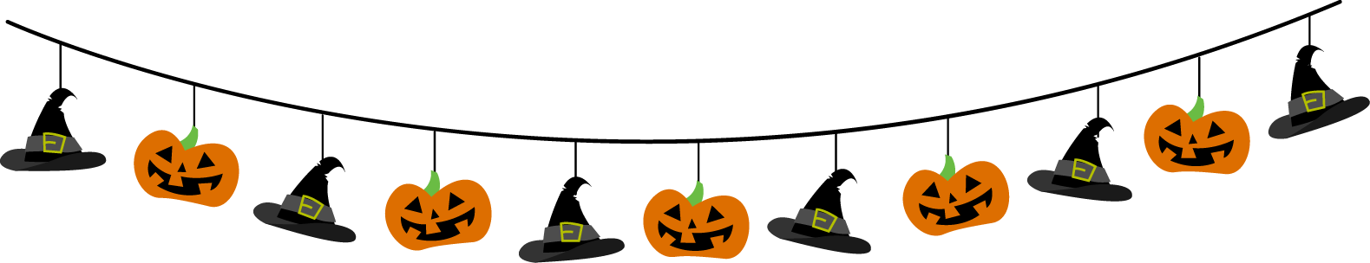

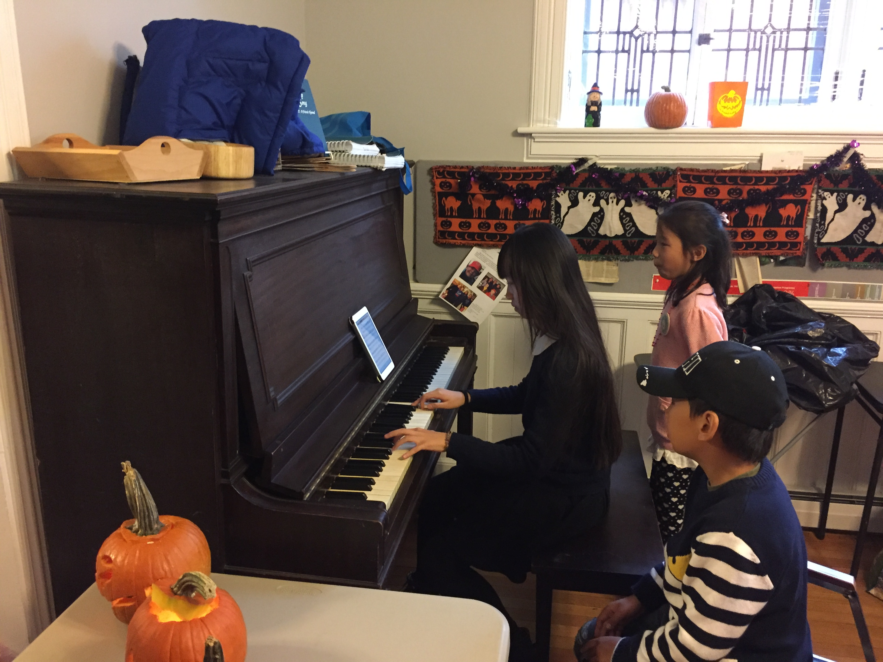
and in his teaching, is learning and combining ancient and often little used techniques, with modern techniques. He showed a video in which some of his students studied with skilled craftsmen that combined ceramics with woven bamboo. They went on to make contemporary examples of this method, combining the skills of modern technology with these ancient techniques. Professor He is well respected in China; He is insightful and inspirational; We are very fortunate to have him presenting this program.
After He's presentations and follow-up discussion, several visiting scholars gave presentations that were related to his topic. It was a very informative and eye-opening afternoon.

USCPFA Halloween Party
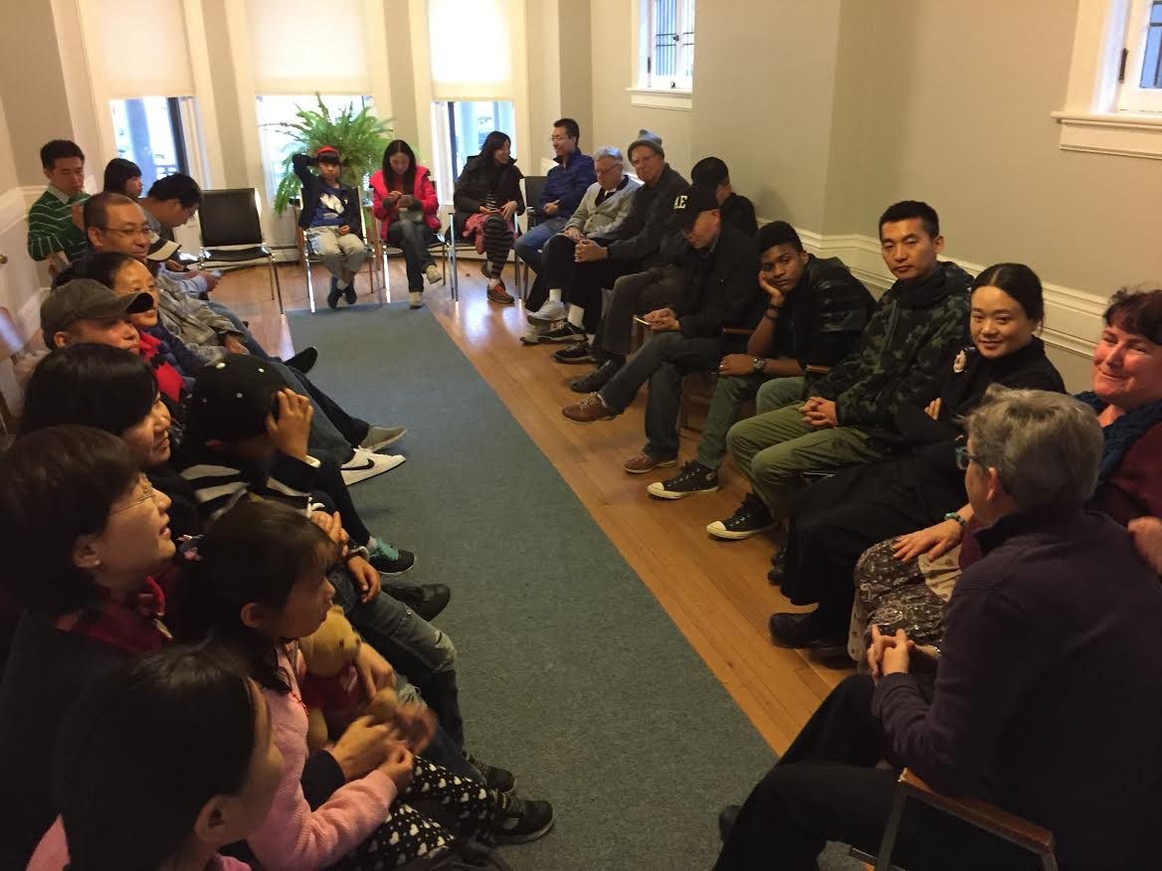

This year’s Halloween party was held on Saturday October 29 at Friends Meeting House during a cloudy afternoon, instead of at night. But that did not stop us from having lots of fun and scary time. As always there were some
Contact information
President: Kirk Huang 518-782-0746 kkhbravo1@yahoo.com
Vice President: Bea Swire 518 -399-7356
Treasurer: Nancy Meyer 518-271-6343 nancearb@gmail.com
Secretary: Alison Stonbely 518-944-1614 devonalison1@yahoo.com
Event Updates: Mel Horowitz 518-449-8817 melschinafriends@yahoo.com
Membership: Lorraine Okeson 518-237-7173 lorraine.okeson@gmail.com
Quick View Calendar
Date | Event | Location | Time | Page
Fri. Dec. 16 | HOLIDAY PARTY | Friends Meeting House, 727 Madison Ave, Albany | 6:00-9:00PM | 1

Quick View Calendar

Membership Application – Make checks out to USCPFA

Name ____________________________________________________

Address __________________________________________________

City, State and Zip __________________________________________

Phone ____________________________________________________

Email ____________________________________________________ Circle one of the above

Amount enclosed* ______________________

Mail to: USCPFA c/o Lorraine Okeson, 10 Watervliet Ave, Cohoes, NY 12047
All memberships include a quarterly copy of the National US-China Review and bimonthly USCPFA Newsletter
* Donations are Tax Deductible to extent allowed by law.

US-China Peoples Friendship Association
President - Kirk Huang

Nov - Dec 2016 Vol.10 Issue 5

Place stamp here

Type of Membership

Student -- $10
Senior -- $20
Individual -- $25
Family -- $40

