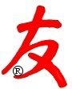

US-China Friendship Newsletter
US-China Peoples Friendship Association
Northeast New York Chapter – Albany
www.uscpfany.org

d High

Mar - Apr 2017 Vol.11 Issue 2

President's Message

Hope you all had a good Chinese New Year.

Our Chapter will hold events in March and April. We have been having a good number of visiting scholars from China attending our events. They are from various parts of China. I encourage you to join our Chapter’s events. Other than having fun at the events, you get to meet the visiting scholars, making friends, exchanging ideas and culture experiences.

See you at our Chapter events. Enjoy the hopefully-soon-to-arrive spring!
Kirk
Kirk Huang
President USCPFA

* Do you have an email address? Send it to Mel if you'd like to be added to our "USCPFA Update" information and reminders

FAMILY FUN! ANNUAL BOWLING TOURNAMENT AND PIZZA PARTY - Saturday March 25

On Saturday March 25, we invite all of our members, Chinese students/scholars and friends to participate in our annual BOWLING AND PIZZA PARTY. We're sure you'll want to join for all the fun, friendship and food for the family.
We’ll meet at DEL LANES, (4 Bethlehem Ct., Delmar 12054 Tel: 518-439-2224) at 2 PM. No experience is needed! Bowling is fun and we’ll be happy to teach you a few tips! We’ll bowl two games and then enjoy freshly baked pizza and soda.
At about 3:30 PM we’ll end with the awarding of special trophies to the best-score male, female and teenagers/children bowlers. The cost of bowling (including bowling shoes) and pizza/soda is only $10 ($5 for children 10 and under) for members, student and scholar friends from China; and $13 for non-members.
We need to plan the number participating. Please let Kirk kkhbravo1@yahoo.com know that you will attend, if you need ride or if you can provide rides.

ANNUAL MEMBERSHIP DINNER EVENT SET FOR SATURDAY APRIL 29

DATE/TIME: Saturday April 29 - Check-in time is 6 PM; We'll begin eating by 6:30 PM.

LOCATION: Capital Buffet (145 Wolf Rd, Colonie) – PRIVATE ROOM.
A REMINDER — Check for any last minute changes on our website at www.uscpfany.org

Events
RESERVATIONS: Only $10 for members and $14 for non-members which includes all the food you can eat, beverage and tips. Not a member but want to pay the same price as members? Simply include your membership dues with your Banquet reservation. Make your reservation early by sending a check (made out to "USCPFA") to Nancy Meyer, 1034 Madison Ave., Troy, NY 12180.
EVENT FEATURES:
(1) Come to enjoy the company of our members and make new friends from China.
(2) Come to enjoy the Chinese and American talented performers.
(3) Come to support the annual Tema Bellinson Memorial Award (for top HS student of Chinese Language & Culture)
Clearly it’s a bargain! We hope you will mark the date on your calendar and plan to attend. If you have any questions please contact Kirk at kkhbravo1@yahoo.com.

Snowshoeing and Potluck Lunch
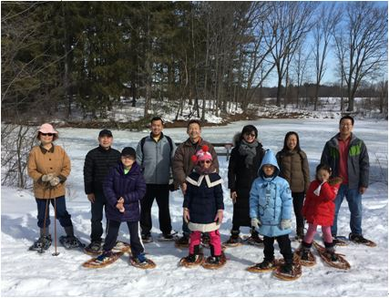
On Saturday February 18, a group of USCPFA members and Chinese visiting scholars went to Five River Environmental Education Center for snowshoeing. We had a couple of big snowstorms the week before. So after several years of not having snow for snowshoeing, we finally were able to go snowshoeing this year. The guide at the Center

first showed us how to put on snowshoes, then took us out snowshoeing on the trail. It was a beautiful and sunny day. We saw deer footprints and winter plants along the way. After the snowshoeing, we went to Delmar Reformed Church for potluck lunch. We enjoyed the delicious food while we had a good conversation. Everyone had such a fun day and looked forward to next year’s snowshoeing.

Cooking Demonstration and Potluck Lunch
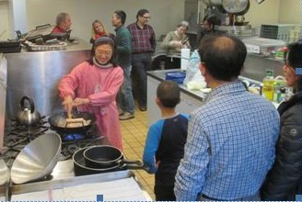

This event was also an occasion to celebrate Chinese New Year.
We had three chefs this year: Dawn Chen. Peter Huston and Wenyang Yang. Dawn was our first chef and she cooked a wonderful “Twice cooked pork with vegetables”. She did an excellent job of demonstrating how to prepare the dish, which was colorful, very attractive looking and delicious. Peter was our second chef. Peter has spent many years living in both China and 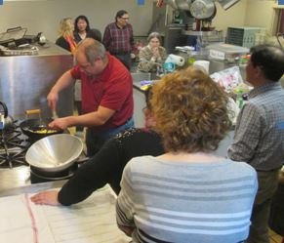
gave some great tips about not overfilling the wok , where to buy the wraps for the Mu Shu, etc.
Our final Chef, Wenyang, made two dishes. His first was "pig trotters with vegetables", the

We had a good turnout for our tenth annual cooking demonstration held on February 11.

Taiwan and has been a long time member of our Chapter. Peter made Mu Shu Pork with vegetables. His dish was also very tasty. He

Events
A REMINDER --Check for any last minute changes on our website at www.uscpfany.org
made from bamboo today. Besides, it is widely used for household articles such as mats, beds, pillows, benches, chairs, cabinets, buckets, chopsticks, spoons, baskets, and handheld fans.

and pine, bamboo and plum as the "three friends in winter." People think its deep roost denote resoluteness, its tall, straight stem represents honorability and integrity, its hollow interior represents modesty and its clean and spartan exterior exemplifies chastity. Bamboo culture always plays a positive role in encouraging people to hold on when facing tough situations.
Throughout the history, bamboo has given inspiration to many artists and is a favorite theme of artwork. Below is a poem of bamboo.

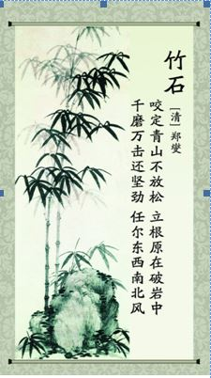
second was "Chinese style breadsticks". The pork had been marinated and cooked for 2 hours in a pressure cooker before the demonstration, so that it was tender and succulent once it was ready. This was also a very colorful dish. "Chinese style breadsticks", which required several folds and cuts and contained black sesame, were sensational right out of the hot oil!
The potluck lunch right after was, of course, a very tasty experience, filled with wonderful conversation, and everybody had a very enjoyable time.
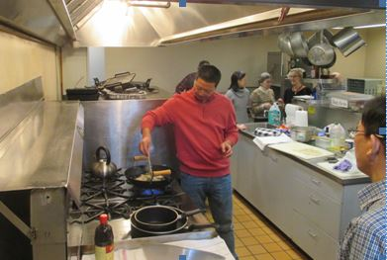

Bamboo and Chinese Culture
edited from http://history.cultural-china.com/
Bamboo is one of China’s most beloved plants. It is not only beautiful and elegant, to the Chinese people, but bamboo is also a symbol of virtue.
As early as the Shang Dynasty (16th-11th century B.C), bamboo was already used in various aspects of ancient Chinese people’s daily lives. China's first books were crafted from bamboo strips strung on strings, and almost all ancient musical instruments were made out of bamboo. People are still using paintbrushes
Contact information
President: Kirk Huang 518-782-0746 kkhbravo1@yahoo.com
Vice President: Bea Swire 518-399-7356
Treasurer: Nancy Meyer 518-271-6343 nancearb@gmail.com
Secretary: Alison Stonbely 518-944-1614 devonalison1@yahoo.com
Event Updates: Mel Horowitz 518-449-8817 melschinafriends@yahoo.com
Membership: Lorraine Okeson 518-237-7173 lorraine.okeson@gmail.com
A poem eulogizing→ bamboo
Translation
＊Biting into the green mountains, never to loose their hold,
＊Deep down the clefts between rocks they strike root.
＊Though and firm they stand against all manners of tear and blow,
＊Mindless of wind, whichever direction it comes from.
The Chinese ancients designated the plum, orchid, bamboo and chrysanthemum as "the four gentlemen,"
Quick View Calendar
Date | Event | Location | Time | Page
Sat. March 25 | Annual Bowling Tournament And Pizza Party | DEL LANES,  4 Bethlehem Ct., Delmar 12054 | 2 PM | 1
Sat. APRIL 29 | Annual Membership Dinner Event | Capital Buffet  145 Wolf Rd, Colonie | 6 PM | 1

Quick View Calendar

Membership Application – Make checks out to USCPFA

Name ____________________________________________________

Address __________________________________________________

City, State and Zip __________________________________________

Phone ____________________________________________________

Email ____________________________________________________ Circle one of the above

Amount enclosed* ______________________

Mail to: USCPFA c/o Lorraine Okeson, 10 Watervliet Ave, Cohoes, NY 12047
All memberships include a quarterly copy of the National US-China Review and bimonthly USCPFA Newsletter
* Donations are Tax Deductible to extent allowed by law.

US-China Peoples Friendship Association
President - Kirk Huang

Mar - Apr 2017 Vol.11 Issue 2

Place stamp here

Type of Membership

Student -- $10
Senior -- $20
Individual -- $25
Family -- $40

