

US-China Friendship Newsletter
US-China Peoples Friendship Association
Northeast New York Chapter – Albany
www.uscpfany.org

d High

May - June -July 2017 Vol.11 Issue 3

President's Message

Although it is spring time, the weather has not been spring-like. Let’s hope there will be some spring weather left for us to enjoy. This year’s membership dinner was another success; good attendance and beautiful American and Chinese entertainment performances. Many Thanks to all who contributed in the success of the event.

Two popular events, hiking and June picnic, will be held in June. I hope to see you at these events.

I wish you a very good and enjoyable summer!

Kirk
Kirk Huang
President USCPFA

* Do you have an email address? Send it to Mel if you'd like to be added to our "USCPFA Update" information and reminders

Springtime Hiking Outing - Sat. June 10

Come join us at our annual hike on Saturday June 10, 2017. The hiking will take place at Albany Pine Bush Preserve, 195 New Karner Rd #1, Albany, NY 12205. Hiking trail will pass through a variety of wildlife habitats and scenic views. Fields, forest and ponds are all part of the hike.
Hiking is a very popular activity and we are looking forward to share this experience with members, students and scholars from China. There is NO FEE! We will meet promptly at
3 PM at the Discovery Center. The Center staff will give our group an introduction of the Preserve. Then we’ll head out for hiking. We suggest you bring a bottle of water, insect repellent and comfortable walking shoes. Sneakers are fine. Some people will bring a hat and sun lotion, as well.
Please call Bea or Bob Swire at (518) 399-7356 to let us know if you are taking the hike—if you need a ride—or if you can provide rides. We request that you leave a telephone number in case bad weather is predicted for the day. Please—NO E-MAILS!
We hope to meet past acquaintances and also make new friends. You might want to bring a camera. After the hike, we may go together for buffet dinner. See you there!

Annual June Picnic – Sunday June 18

Our Annual June Picnic will be held at the Bethlehem Town Park located at Elm Ave, Pavilion A (small pavilion), in Delmar, NY from 12:00 PM to 4:30 PM on Sunday June 18. We invite all members and Chinese friends to join the fun and welcome summer. Just in case it

A REMINDER — Check for any last minute changes on our website at www.uscpfany.org

Events
rains, we have reserved the pavilion. There will be food, friendship and games! USCPFA will provide hot dogs, buns and soda. To enhance the food, you are asked to bring a dish, salad or fruit to share. There are usually too many desserts, therefore something other than dessert would be much welcome.
We do need to know how many are attending so that we will have enough food. So please let Kirk (kkhbravo1@yahoo.com) know how many of you will attend. Please also let him know if you need a ride or can provide rides.

Annual Bowling and Pizza Party

Pizza and bowling at Del Lanes is always a lot of fun and this year was no exception! On Saturday March 25, everyone bowled at their own skill and grew excited when they made a strike! Our Female Champion, Joyce, has been a winner several times. The men’s Championship, as is often the case, was a close competition. In the end, David Wang, a visiting scholar, was our champion. Our member, Dave Sutor, was second place. The teenager Championship went to Jenny Peng, daughter of a visiting scholar. A good time was had by all, with Rezsin observing and cheering from the sideline. After Bowling it was time to eat Del Lanes’ delicious house made pizza. Trophies were awarded to the winners. We had lots of good conversation and laughter. If you have not attended before, why not come next year?

Annual Membership Dinner
Many of our members and friends from China gathered at the Capital Buffet on Wolf Rd in Colonie on Saturday evening April 29th for our Annual Dinner. After we had ample time to eat, drink and enjoy conversations, Kirk welcomed everyone and talked about the USCPFA and our upcoming programs.
Kirk then introduced Chinese Language Teacher Sophia Hsia to present the Tema
Bellinson Award to the Capital Region's most outstanding high school student of Chinese Language and Culture. This year's honoree is Tech Valley HS Senior Sydney Hayes, a student currently taking Chinese 4. In 2015 Sydney visited China with a group of 20 students and staffers from Tech Valley HS. Also attending was Diana Bennett, an assistant to Congressman Paul Tonko, who presented congressional certificates to Sydney.
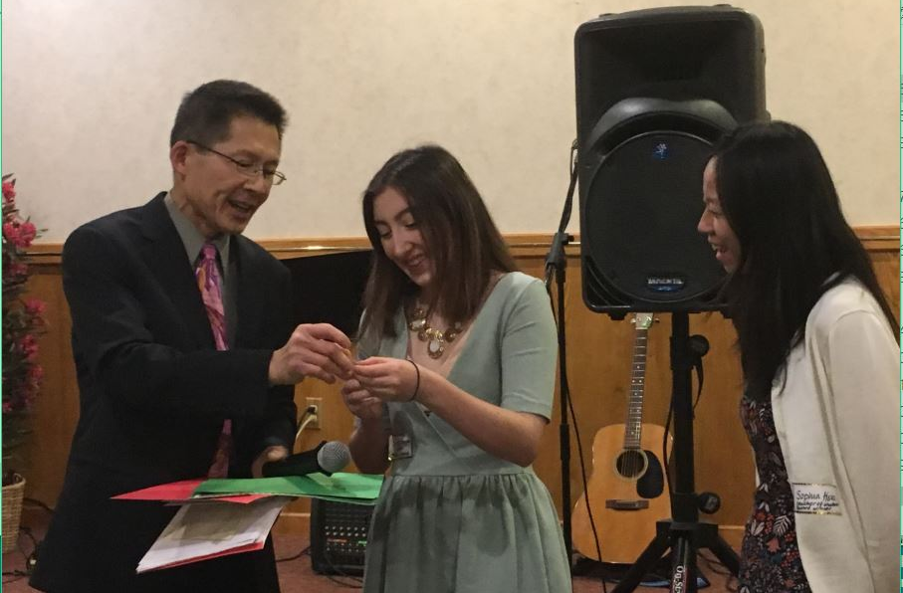
After the awards, we enjoyed excellent American and Chinese Music. Nick Bisanz and Peter Warren provided vocals and played the guitar on a number of American folk and jazz songs. Then followed by visiting scholar, HuiJing Chen and her daughter, Amy Chen, played couple songs lovely on a piano keyboard. Their piano teacher, Daisy Lin who played for us before, closed the entertainment by playing several beautiful piano pieces. A wonderful evening was enjoyed by all!
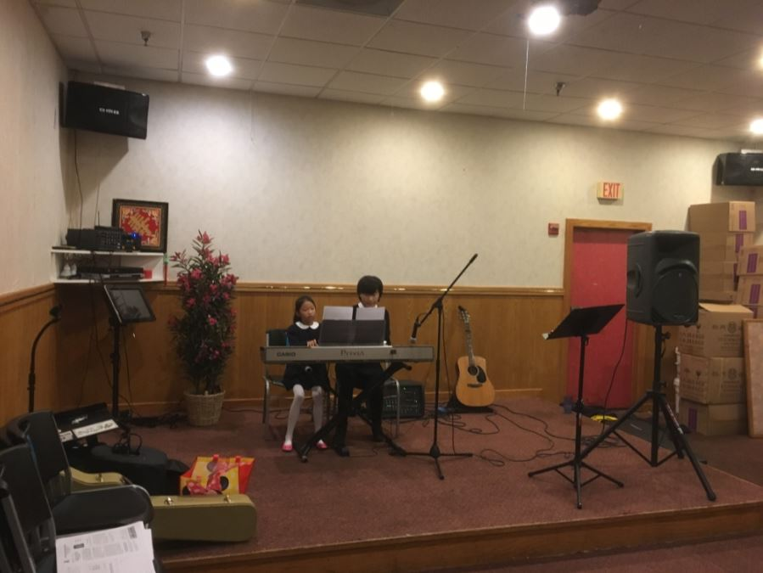

INTERESTING INFORMATION
A REMINDER --Check for any last minute changes on our website at www.uscpfany.org
Land of Bridges, Quanzhou is a land of bridges, both literally and metaphorically. Start of the "Maritime Silk Road," it was not only the commercial and cultural bridge between China and the rest of the planet, but it also gave us some of the world’s most unique bridges, spanning rivers, gorges, and bays.
What does a covered bridge mean to the villagers around? During rain and heavy winds, covered bridges are the people’s umbrellas. When temperatures soar, these bridges are the best places to avoid sunstroke and stay cool. Covered bridges are also an important place for socializing and entertainment. As key traffic areas, they are also natural marketplaces where local people set up stalls and do business, and sometimes the bridges are even the launching pads for new romances.
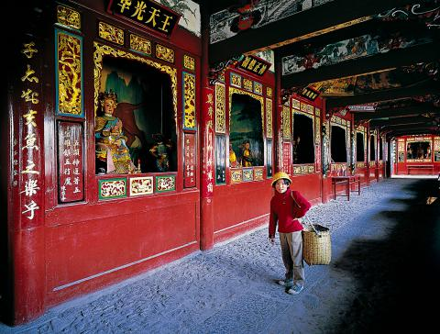
Covered bridges usually have a shrine in the middle, and religious paintings on the beams above.

On the middle of the bridge, arched a pavilion with a large span, for people to lounge and rest, on the roof of which fly three pairs of cornices; Looking from a far distance, the entire bridge is just like two rainbows. And with such a typical Hakka architecture style, the form of this bridge is definitely unique in China.
The Covered Bridges of China
--connecting people for 2,000 years
Source: http://www.amoymagic.com/bridges.htm
& From Lu Xiaomin's article of the same title
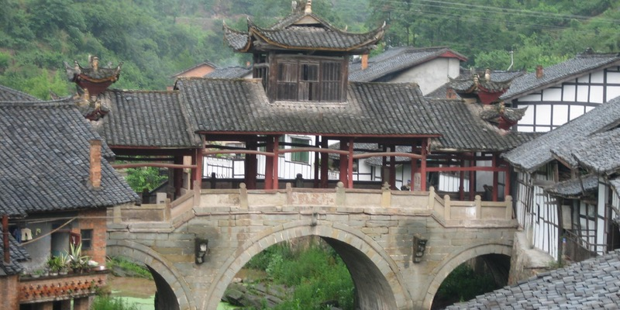
According to preliminary study, China still has more than 3,000 covered bridges preserved from ancient times after weathering through all the winds and storms. They stride dangerous rapids, cliffs and quiet villages, throughout the country, carrying on the legacy of Chinese culture. These covered bridges are distributed throughout 20 provinces, among them Fujian having the highest density. A Chinese saying tells us: “Central Fujian bridges are second to none under heaven”
Excerpt from "In and About Amoy" (Amoy is the former name of Xiamen, Fujian Province)
The bridges of China are wonders! On some of them people build their temples and houses and shops--where they live and carry on their business. There are at least two bridges of this kind in the Amoy district, each having a population of from fifty to one hundred inhabitants--perhaps more. These bridges are generally of wonderful construction. How the largest of them were built must always remain a matter of pure conjecture. “Twenty-five miles west of Amoy there is a famous bridge...There are natives who will tell you that man could not have lifted, by any imaginable machinery, to their present position those immense stones of which it was made. The only conclusion they can come to is the gods must have done the work.

Contact information
President: Kirk Huang kkhbravo@yahoo.com
Vice President: Bea Swire 518 -399-7356
Treasurer: Nancy Meyer 518-271-6343 nancearb@gmail.com
Secretary: Alison Stonbely 518-944-1614 devonalison1@yahoo.com
Event Updates: Mel Horowitz 518-449-8817 melschinafriends@yahoo.com
Membership: Lorraine Okeson 518-237-7173 lorraine.okeson@gmail.com
Taiping Bridge (Peace Bridge), Zhejiang Province, is a stone arch bridge. It was built in 1505-1521 AC.

Quick View Calendar
Date | Event | Location | Time | Page
Sat. June 10 | Springtime Hiking Outing | Albany Pine Bush Preserve, 195 New Karner Rd #1, Albany, NY 12205. | 2 PM | 1
Sun. June 18 | Annual June Picnic | Bethlehem Town Park Pavilion A (small pavilion), Elm Ave, Delmar, NY | 12:00 PM- 4:30 PM | 1

Quick View Calendar

Membership Application – Make checks out to USCPFA

Name ____________________________________________________

Address __________________________________________________

City, State and Zip __________________________________________

Phone ____________________________________________________

Email ____________________________________________________ Circle one of the above

Amount enclosed* ______________________

Mail to: USCPFA c/o Lorraine Okeson, 10 Watervliet Ave, Cohoes, NY 12047
All memberships include a quarterly copy of the National US-China Review and bimonthly USCPFA Newsletter
* Donations are Tax Deductible to extent allowed by law.

US-China Peoples Friendship Association
President - Kirk Huang

May - June - July 2017 Vol.11 Issue 3

Place stamp here

Type of Membership

Student -- $10
Senior -- $20
Individual -- $25
Family -- $40

