

US-China Friendship Newsletter
US-China Peoples Friendship Association
Northeast New York Chapter – Albany
www.uscpfany.org

d High

=www.uscpfany.org II. Gr
November – December 2017 Vol.11 Issue 5

President's Message

It has been a warm fall season so far. I enjoy it very much because I still can do many outdoor activities.

Thanksgiving is coming! If you like to invite some visiting scholars or students from China to your home for Thanksgiving, please contact me.

I look forward to seeing you at our Speakers Program in November and Christmas Party in December.

I wish you and your loved ones a very happy Holiday Season! Kirk

Kirk
Kirk Huang
President USCPFA

* Do you have an email address? Send it to Mel if you'd like to be added to our "USCPFA Update" information and reminders

Speaker Program - Saturday November 11
A Glimpse of Yunnan Cultural-linguistic Diversity in China

On Saturday November 11, 2017 at Colonie Library, 2-5 PM, Dr. Qinghua Peng, professor & deputy-dean of School of Foreign Languages & Literature, Yunnan Normal University; senior visiting scholar at SUNY Albany, will introduce ethnic groups in Yunnan Province. Yunnan has the largest numbers of ethnic groups in China. It is reported that, of 56 nationalities/ ethnic groups in China, there are 52 living in Yunnan Province. Among the 52 ethnic groups, 15 of them, the Bai, the Hani, the Lisu, the Wa, the Lahu, the Nakhi, the Jingpo, the Blang, the Pumi, the Achang, the Jino, the Nu, the Deang, and the Derung, live in no other place but Yunnan. They could be named “indigenous ethnic groups”. This presentation will give you a look at their life and culture.

HOLIDAY PARTY – Saturday December 9

Our Annual Holiday Party will take place on Saturday, December 9th from 6 PM to 9 PM at Friends Meeting House, 727 Madison Ave, Albany. We'll start with potluck dinner. EVERYONE PLEASE BRING A DISH OR FOOD TO SHARE. We'll sing, tell stories, and have fun. All are welcome. Please let Kirk kkhbravo1@yahoo.com know that you are attending, and if you need a ride, or you can provide rides. See you at the Party!
A REMINDER — Check for any last minute changes on our website at www.uscpfany.org
Events

Halloween Party
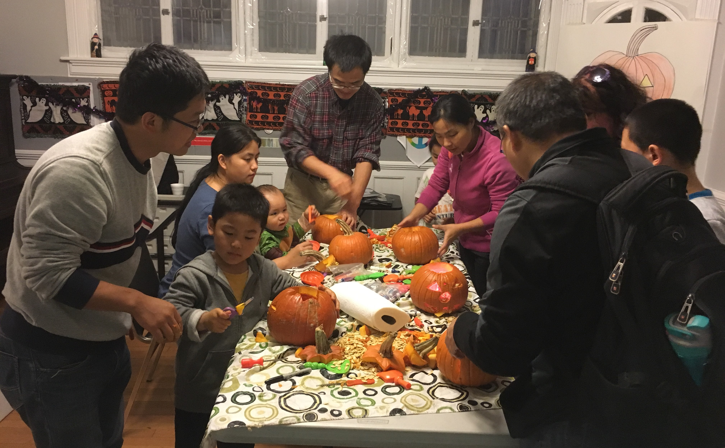
We had a nice crowd for our Annual Halloween party at the Friend‘s meeting house in Albany. We started as always by carving pumpkins, which is hard work, but great fun. As always, pin the stalk on the pumpkin, had several volunteers and gave a few laughs all around. The kids always seem to have fun with our pumpkin toss game.
After dinner, the lights were turned off and the carved pumpkins were lit and we were treated to some of Mary Murphy’s super scary stories. Two boys share ghost stories too. By the time we left, everyone looked over their shoulder twice to check for uninvited visitors!
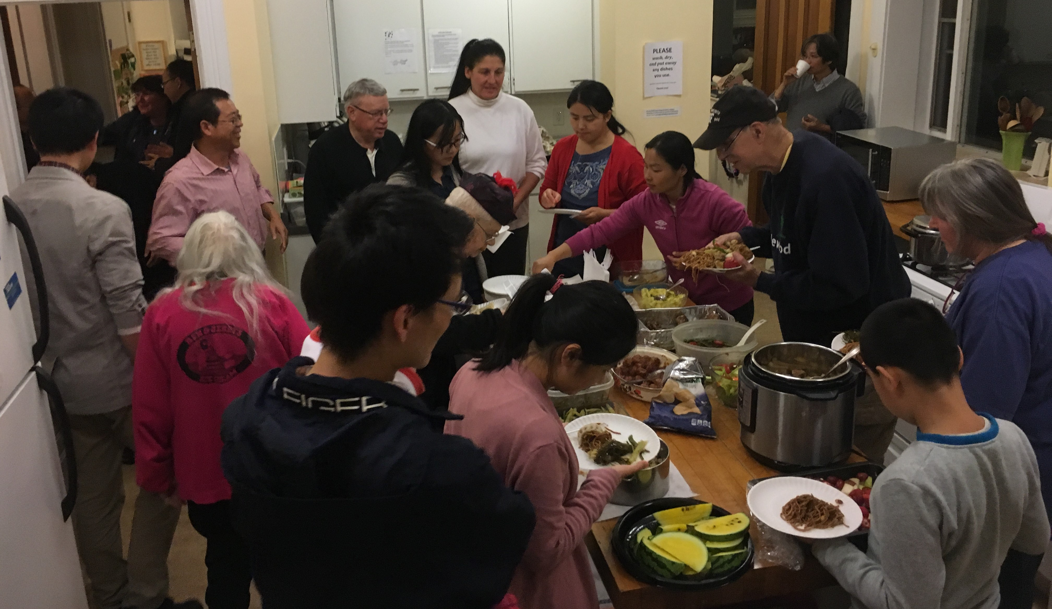

Masters of the Forbidden City--A phenomenal Hit Documentary
Timeless Treasures
The Palace Museum (Forbidden City) is home to China’s largest collection of relics, with over 1.8 million documented pieces collected during the Ming and Qing Dynasties between 1420 and 1912. After China’s last emperor, Pu Yi, was overthrown
Tri-City Valley Cats Baseball Game
On Friday August 25, a group of US-China Peoples Friendship Association (USCPFA) members and our friends from China were at our annual China Friendship Night at the Joe Bruno Stadium on the Campus of HVCC to watch a professional baseball game and cheer for our local Tri-City Valley Cats. Visiting Scholars and their children were there as our members explained the basics of the game to those who were unfamiliar with baseball. Many saw the baseball game for the very first time but they were fast learners. Although the Valley Cats lost the game (4-0), we still had a lot of fun both watching the game and enjoying friendship.
Welcome Picnic
We had a great turnout for our Welcome Picnic at Bethlehem Park on August 26 2017; quite a few USCPFA members and new and current visiting scholars from China attended. The weather was perfect; it was warm with a slight breeze. As always at the welcome picnic, one or two of the visiting scholars had arrived literally days before the picnic. Everyone introduced themselves. Good conversation and food was shared by all. After the picnic and conversation, some took a pleasant stroll in Bethlehem Park on one of the trails, where we continue converse. Everyone had a very enjoyable afternoon.
September Hiking
On Saturday September 23, a beautiful warm sunny day, a group of USCPFA members and Chinese visiting scholars took a hiking at Albany County Rail Trail. The Rail Trail follows the path of the former Delaware & Hudson (D&H) Railroad and, later, the Canadian Pacific Railway, which stopped using the corridor in 2003. Along the way, trail-goers can access Veterans Memorial Park in Delmar and Fireman's Park in Slingerlands. Much of the trail is quiet and wooded; part of the trail offers views of Normanskill creek. Our President, Kirk, a civil engineer, introduce to the group the structural features of the bridges along the hiking trail. Everyone gained knowledge and appreciation of bridge engineering. The entire hiking took about 3 hours. Although a little bit tired, everyone enjoyed the hike and the beautiful sceneries.

Events
A REMINDER --Check for any last minute changes on our website at www.uscpfany.org
series closely follows the restorers and shows the relationship between people and relics, individuals and scenarios, people-to-people, in a natural setting. Instead of experts, what appears in the camera are real people with personalities, people who play guitars and make jokes about each other after a long day of restoration work. The documentary shows a deep respect to individuals and generates a strong sense of immersion.
Narrative pace
The stories are told in a slow and leisurely pace, closely capturing the restorers' working and living status. Restoration of cultural relics and antiques is time-consuming, and sometimes boring. Yet these restorers' patience and persistence and their tranquil lifestyle are especially precious in a society where everything is changing so fast. The camera captures their devotion to work and their attitude to life.
"If you choose this job, you would have to endure hours of work sitting on the chair. You need to be quiet and get used to being quiet," said Wang Jin, ancient clock repair expert, says in the documentary. This exact sense of tranquility and persistence is visible throughout the series.
Craftsmanship spirit
What is more touching in the documentary is the craftsmanship spirit embodied in these restorers. Years of humdrum work requires not only skill, but also faith and spirit. The pursuit of preciseness and perfection, devoting to work, strong patience, endurance to loneliness...all these qualities are a vivid interpretation of "craftsman spirit". This lifts and broadens the theme of the documentary.
Master In Forbidden City delicately tells the stories of both modern individuals and historical cultural relics, in a touching yet natural way. No doubt people loved it so much.

by revolutionaries, this once-impenetrable imperial palace was turned into a museum in 1925 and opened to the public.
A Chinese documentary featuring the Forbidden City's cultural relics and their restorers' lives became a surprise hit. Called Master In Forbidden City, the documentary shines light on the unsung life stories of restorers of cultural relics working inside the Forbidden City, together with the history of the antiques and the palace, the procedures of restoration and the development of cultural protection. Later it was adapted into the big screen with the same title.
Compared with movies and TV shows, a documentary focused on history and culture rarely becomes so much popular. So what’s the secret behind its huge success?

Human touch
Even though the stories take place in the historical Forbidden City and the cultural relics are a key element of it, the documentary does not dwell on the past. Instead, the camera focuses on the ordinary individual human beings -- the restorers, and their life in Beijing, which creates a bond between the audience and the restorers and bridges the gap between the narrator and the viewer. Instead of using panorama images and bird’s-eye views, the TV
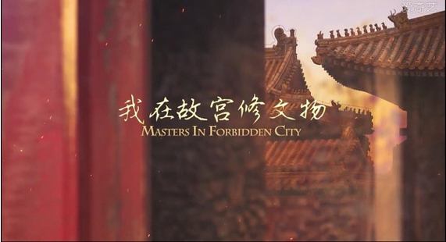
Contact information
President: Kirk Huang 518-813-9104 kkhbravo@yahoo.com
Vice President: Bea Swire 518 -399-7356
Treasurer: Nancy Meyer 518-271-6343 nancearb@gmail.com
Secretary: Alison Stonbely 518-944-1614 devonalison1@yahoo.com
Event Updates: Mel Horowitz 518-449-8817 melschinafriends@yahoo.com
Membership: Lorraine Okeson 518-237-7173 lorraine.okeson@gmail.com
Quick View Calendar
Date | Event | Location | Time | Page
Sat. Nov 11 | Speaker Program | Colonie Library | 2 - 5 PM | 1
Sat. Dec 9 | HOLIDAY PARTY | Friends Meeting House, 727 Madison Ave, Albany | 6 - 9 PM | 1

Quick View Calendar

Membership Application – Make checks out to USCPFA

Name ____________________________________________________

Address __________________________________________________

City, State and Zip __________________________________________

Phone ____________________________________________________

Email ____________________________________________________ Circle one of the above

Amount enclosed* ______________________

Mail to: USCPFA c/o Lorraine Okeson, 10 Watervliet Ave, Cohoes, NY 12047
All memberships include a quarterly copy of the National US-China Review and bimonthly USCPFA Newsletter
* Donations are Tax Deductible to extent allowed by law.

US-China Peoples Friendship Association
President - Kirk Huang

November – December 2017 Vol.11 Issue 5

Place stamp here

Type of Membership

Student -- $10
Senior -- $20
Individual -- $25
Family -- $40

