

US-China Friendship Newsletter
US-China Peoples Friendship Association
Northeast New York Chapter – Albany
www.uscpfany.org

d High

Aug - Sept - Oct 2018 Vol.12 Issue 4

President's Message

It has been a warm summer this year. I love it! Summer is so short in our area, I welcome and enjoy every summer day.
Our Chapter will hold interesting and fun events in the fall. I hope you will come joining the events. Other than seeing old acquaintances at events, it is also an opportunity to meet Chinese scholars and students to learn about China, and to develop friendship.
I am honored to be re-elected President for another term. Thank you very much for the support. If you have suggestions about our Chapter, events or any topic, please do not hesitate to contact me.
Enjoy remaining summer and upcoming fall! See you at the events!

Kirk
Kirk Huang
President USCPFA

* Do you have an email address? Send it to Mel if you'd like to be added to our "USCPFA Update" information and reminders

ANNUAL US-China Night at the Tri-City Valley Cats Baseball Game – Tuesday August 21, 2018
We hope that many of our members and friends will join us on Tuesday August 21 for the annual US-China Peoples Friendship Association (USCPFA) China Friendship Night at the Joe Bruno Stadium on the Campus of HVCC (Hudson Valley Community College) in Troy. This is an opportunity to watch a professional baseball game and cheer for our local Tri-City Valley Cats. Thanks to the Valley Cats and National Grid, tickets are FREE for members, your family (children are urged to joins) and, of course, all area students and scholars from China.
As usual, the Valley Cats (a farm team of the world champion Huston Astros), are doing well. This year we will see them play against the Brooklyn Cyclones. There is always a lot of fun, entertainment and contests at these games.
The game begins at 7 PM but on August 21 the gates open at 5 PM with a LIVE BAND CONCERT from 5-6:30! To help us get into the concert spirit most beers are 2 for 1 that night!
We hope that many of our Chinese friends will join our group. As some from China are not familiar with baseball we urge our members to help explain the game to them. To celebrate the China friendship we will select one of our friends from China (probably a youngster) to have the honor of throwing out the opening game ball!
Advance reservations are REQUIRED! To reserve your tickets please contact Mel at melschinafriends@yahoo.com or
A REMINDER — Check for any last minute changes on our website at www.uscpfany.org
Please email Kirk at kkhbravo1@yahoo.com if you are taking the hike, if you need a ride or if you can provide rides. We request that you leave a telephone number in case bad weather is predicted for the day.

Halloween Party – Saturday October 27th

Halloween is a favorite holiday for adults and children alike. It is when ghosts come out to walk in the night. Children go door to door for candy treats and everyone parties. This year we'll celebrate Halloween, on Saturday October 27th, 5 PM - 9 PM at the Friends Meeting House, 727 Madison Ave, Albany N.Y. You may wear a costume if you wish. There will be pumpkin carving, games, and a Pot Luck supper and storytelling. We'll have a lot of fun! PLEASE BRING A DISH TO SHARE! Contact Alison at devonalison1@yahoo.com or 518 944 1614 if you wish to attend, if you need a ride or can provide rides. Everyone is welcome! Come enjoy the fun!

Springtime Hiking

Sunday June 17, a group of visiting scholars, their children and our members, hike on Mohawk-Hudson Trails which is along the scenic Hudson River. We stopped to see scenery of Hudson River. Kirk introduced various structural types of bridges to the group along the hiking trail. Although it was a warm day, we all were in high spirit. Children had the most energy playing all the way. The hiking took about 2 ½ hours. We then took a rest and had very good conversation under the tree shade. Afterwards we headed to the favorite place, ice cream shop! Everyone enjoyed cold, delicious ice cream, and had a wonderful hiking day.
Annual June Picnic

Because the original date was a rainy day, our Chapter held the annual June picnic on
Events
518-449-8817. Mel will need your name, phone number and how many people. It is important that you make reservation ASAP. Please let Mel know if you need a ride or can offer rides. We look forward to seeing YOU there!

WELCOME PICNIC – Sunday August 26

Be sure to join us (USCPFA) on Sunday August 26 to give a big welcome to the incoming and returning students and scholars that attend the colleges and universities in our area. The picnic will be held at Elm Avenue Park, 261 Elm Avenue, Delmar, NY 12054 Pavilion A (small pavilion), starting at 12 PM ending around 4 PM. Everyone who plans to attend, please bring a dish, food or dessert to share. USCPFA will provide hot dogs, buns, and soda. There will be delicious food and good conversation. We’ll also take a short hike on park trails. Please contact Kirk at kkhbravo1@yahoo.com to confirm your attendance, if you need ride, or if you can provide rides.

Fall Hiking – Sunday October 7th

Fall is a beautiful colorful time of a year. The leaves turn into many beautiful colors especially under the sunlight. We would like you to join us on a hike at Schoharie Crossing State Historic Site on Sunday October 7th, 2018.
The Hiking Trail follows Mohawk River, which is also New York State Barge Canal. At the eastern end of the site is the Putman Lock Stand at Yankee Hill that houses an exhibit on Erie Canal stores. The site's largest structure is the remains of the Schoharie Aqueduct, which carried the water of the Enlarged Erie Canal over the Schoharie Creek.
There is NO FEE! We will meet promptly at 1 PM at the Visitor Center, 129 Schoharie Street, Fort Hunter, NY 12069.

Events
A REMINDER --Check for any last minute changes on our website at www.uscpfany.org
served as the ancient capital city for the historical 13 dynasties with connected periods of over 1000 years. Xi’an was the capital of Tang Dynasty (618 – 907) for 286 years. Tang Dynasty is one of the most developed dynasties in China history and the most advanced country around the world during that period.
The Great Tang All Day Mall is the largest and longest pedestrian street of tourist landscape and cultural mall in Asia'. It's all a tribute to the Great Tang Dynasty culture and the key project to rejuvenate the great Tang Dynasty. It is more than just a traditional mall, but a sightseeing traffic-free avenue along a 1500-meter axis from the Big Goose Pagoda down to the south, linking three themed squares – Xuan Zhuang Square, Zhenuan Cultural Square and Kaiyuan Ceremony Square based on the Tang Dynasty cultural backgrounds and elements including the buildings of Tang architectural style and sculptures devoted to great leaders, monks, artists, writers, poets, scientists and mathematicians of the Tang Dynasty. It is a one-stop consumers’ paradise where you are immersed in Tang Dynasty culture while enjoying shopping, dining, entertaining, sightseeing and business travel. Seeing this area at night is totally different than during the day as the lighting is 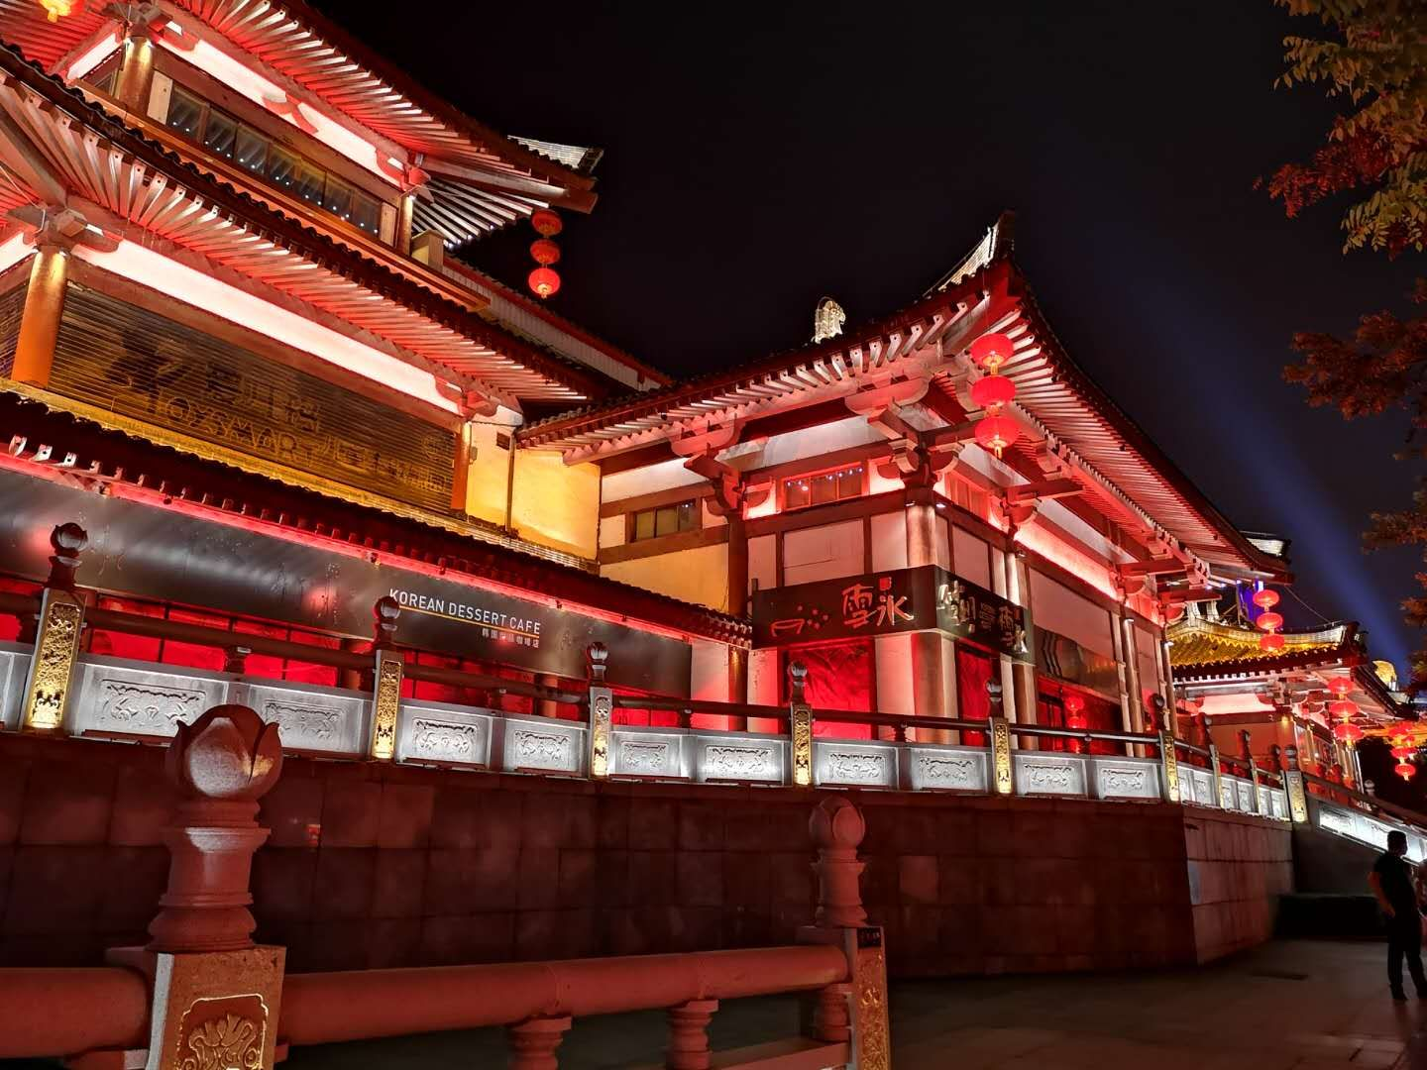
July 1 instead. The afternoon temperature was 97 F (record was 99 F). Despite of hot temperature, a group of 25 members, visiting scholars and their children attended the picnic. Same as past years, Kirk cooked delicious hot dogs under the scorching sun and charcoal heat. In addition to hot dogs, we tasted the delicious food everyone brought. The watermelon was particularly popular this year due to hot weather. During the talk, Kirk mentioned the 3 attending visiting scholars who would go back to China in August and thanking them for supporting our events, and wished them the best. Then our members present at the picnic elected Chapter Officers for another 2 year term: Kirk – President, Bea – Vice President, Nancy – Treasurer, Alison – Secretary. Everyone had a wonderful time and looked forward to the next event.

Great Tang All Day Mall – A Place Full of History and Wonder


Great Tang All Day Mall(大唐不夜城), located in Xi'an, Shanxi Province, is like a sleepless city inside a city.
Xi'an is well-known for its world-famous Terracotta Warriors over 2000 years back. But there is much more to see in Xi’an, which once

Contact information
President: Kirk Huang kkhbravo1@yahoo.com
Vice President: Bea Swire 518 -399-7356
Treasurer: Nancy Meyer 518-271-6343 nancearb@gmail.com
Secretary: Alison Stonbely 518-944-1614 devonalison1@yahoo.com
Event Updates: Mel Horowitz 518-449-8817 melschinafriends@yahoo.com
Membership: Lorraine Okeson 518-237-7173 lorraine.okeson@gmail.com
astonishingly marvelous yet tastefully done, ending the visit with unforgettable memories.

Source: TripAdvisor,
Tour-Beijing.com ,
www.chinaxiantour.com
Quick View Calendar
Date | Event | Location | Time | Page
Tue. Aug. 21 | Annual China Friendship Night Baseball Game | Joe Bruno Stadium  Campus of HVCC, Troy | 7 PM | 1
Sun. Aug. 26 | WELCOME PICNIC | Elm Avenue Park, Pavilion A, 261 Elm Avenue, Delmar, NY | 12 PM - 4 PM | 2
Sun. Oct. 7 | Fall Hiking | Visitor Center,  129 Schoharie Street  Fort Hunter, NY 12069 | 1 PM | 2
Sat. Oct. 27 | Halloween Party | Friends Meeting House, 727 Madison Ave, Albany | 5 Pm – 9 PM | 2

Quick View Calendar

Membership Application – Make checks out to USCPFA

Name ____________________________________________________

Address __________________________________________________

City, State and Zip __________________________________________

Phone ____________________________________________________

Email ____________________________________________________ Circle one of the above

Amount enclosed* ______________________

Mail to: USCPFA c/o Lorraine Okeson, 10 Watervliet Ave, Cohoes, NY 12047
All memberships include a quarterly copy of the National US-China Review and bimonthly USCPFA Newsletter
* Donations are Tax Deductible to extent allowed by law.

US-China Peoples Friendship Association
President - Kirk Huang

Aug - Sept - Oct 2018 Vol.12 Issue 4

Place stamp here

Type of Membership

Student -- $10
Senior -- $20
Individual -- $25
Family -- $40

