

US-China Friendship Newsletter
US-China Peoples Friendship Association
Northeast New York Chapter – Albany
www.uscpfany.org

d High
January – February 2018 Vol.12 Issue 1

President's Message

Happy New Year! Hope you had an enjoyable holiday season. Our Chapter had a successful 2017! My appreciations to our members for their continuing support, and to the organizations that allow us to use their facilities to hold events. Please come joining the exciting 2018 Chapter events and rekindle old friendship and make new friendship.
This year’s Chinese New Year is on February 16. This is the year of the Dog. I wish you and yours a Happy, Healthy, Prosperous and Successful 2018 and the Year of the Dog! Looking forward to seeing you at our events!
Kirk
Kirk Huang
President USCPFA

* Do you have an email address? Send it to Mel if you'd like to be added to our "USCPFA Update" information and reminders

WINTER FUN ! GO SNOWSHOEING and LEARN ABOUT NATURE then join POTLUCK LUNCH and CONVERSATION
Saturday February 3 - 9:30 AM to 2:30 PM

On Saturday, February 3rd, we will go SNOWSHOEING at the Five Rivers Environmental Education Center, 56 Game Farm Rd, Delmar, NY 12054. This is an annual FAMILY event for our members, students and scholars from China and including children. You will need to arrive by 9:30 AM. Five Rivers charges $5 rental fee for using snowshoes. Therefore you will pay the $5 rental fee if you use their snowshoes.
When we begin, the guides at the Center will explain how to put on and walk on snowshoes, and then we will go for a walk in snowshoes to walk on top of the snow. Let's hope we actually have snow, but we'll have a walk even if there is none. They will show us animal prints and explain how they survive in winter. Be sure to dress warmly. Dress in layers. We should finish our walk by around 11:30 AM.
Next we will enjoy potluck lunch and friendly conversation at the Delmar Reformed Church located at 386 Delaware Ave, Delmar. Everyone is asked to bring food to share at the lunch - main dishes are encouraged; Please make a reservation with Kirk at kkhbravo1@yahoo.com, and also let him know if you need a ride or can offer rides.
Annual Chinese Cooking Demonstration and Potluck Lunch
Saturday February 24th, 2018

On Saturday, February 24th, 2018, we will be hosting our 11th annual cooking demonstration at the Westminster Presbyterian Church, which is located at 85 Chestnut St, Albany, from 11:30 AM – 3:30 PM. We are
A REMINDER — Check for any last minute changes on our website at www.uscpfany.org
Professor Peng and the audience. The audience all left with better understanding of ethnic minorities in Yunnan. Many thanks to Professor Peng for the insightful presentation.

USCPFA Holiday Party

Despite slippery conditions and snow, we had a pretty good turnout for our Annual Christmas party on Saturday December 9th. The children started by decorating snowflakes and stockings. The potluck dinner that followed was delicious and accompanied with cheerful conversation. Mary and Alison recited “Twas the night before Christmas” before Mary told three wonderful stories. We ended the evening singing Christmas carols, before going out into the night of improved weather conditions. We missed our friends who were unable to attend because of the wintry condition and hope that next year’s weather will make travel easier for all.

Winter Solstice In China — An Old Traditional Holiday Becomes Alive Again

More and more people celebrate Winter Solstice
(冬至DongZhi) in China nowadays. Although when we were little, it didn’t get much attention. It now means celebration, feast and family reunion — everything you hope to have in Spring Festival and is considered as important as Spring Festival in many parts of China.
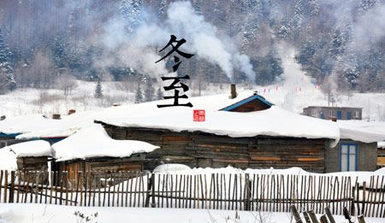 Winter solstice is a very important solar term in Chinese Lunar calendar as well as a traditional holiday. Early during the Spring and Autumn period, which was more than 2500 ago, Chinese people adopted the methods of tugui to measure the shadow of the sun for determining the twenty-four
fortunate enough to have several chefs who are visiting scholars and Americans who are all excellent chefs. They will give us easy to follow step-by-step directions, so that both the novice and the expert will be able to recreate the dishes.
Come out of the cold and learn something new this Chinese New Year, you will not be sorry!! After the demonstration you will be able to sample the dishes that chefs make as well as
share the dishes you and others bring, with warm conversation. Please bring a dish to share at the potluck! This is a popular event, which is enjoyed by both Chinese and Americans alike, so please contact Kirk at
kkhbravo1@yahoo.com if you wish to attend.
Speaker Program

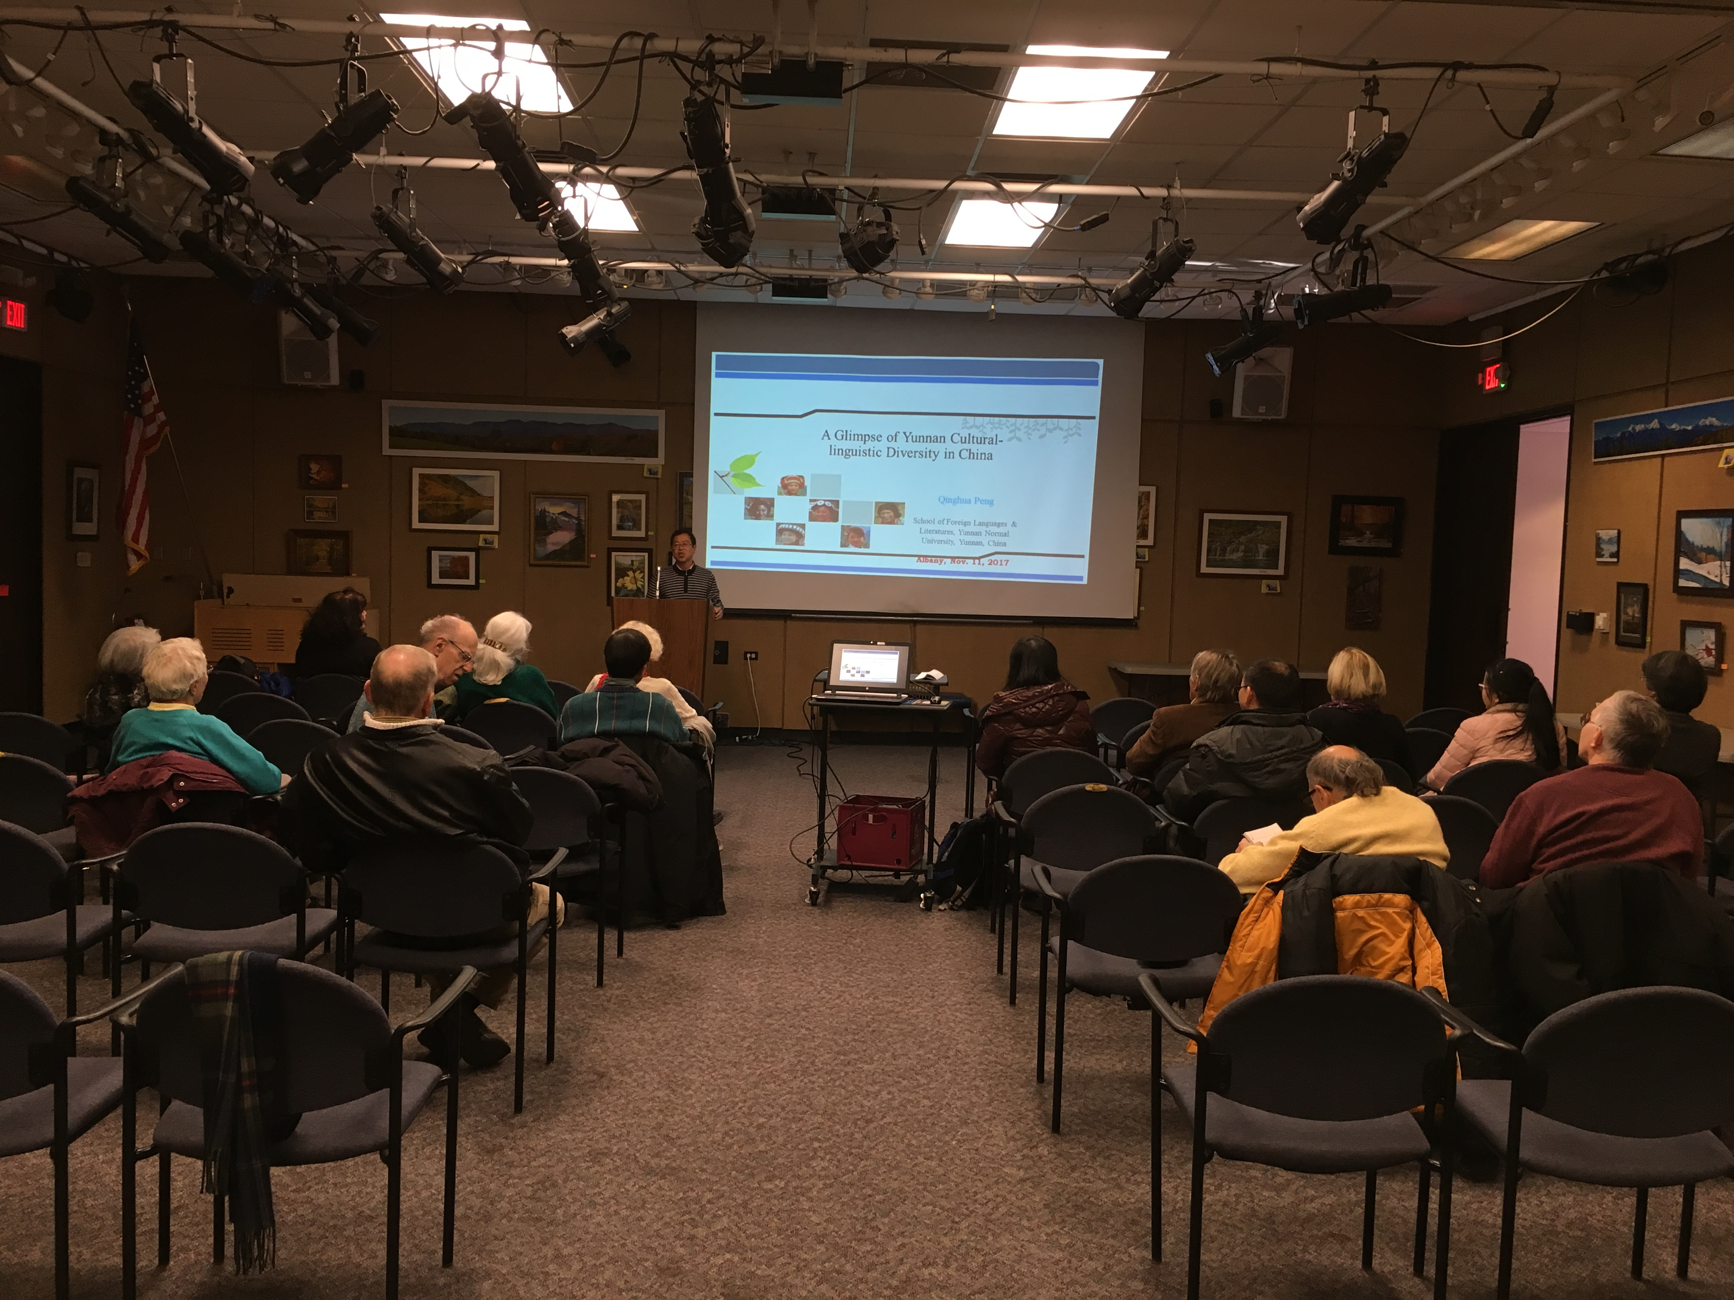

On November 11th at Colonie Library, Professor Qinghua Peng from Yunnan Normal University, currently a senior visiting scholar at SUNY Albany, gave a presentation on ethnic minorities in Yunnan Province. Yunnan, an underdeveloped province in the southwestern part of China, bordering on the countries of Vietnam, Laos, and Burma, has the richest diversity of ecosystem including natural environment and ethnic culture in China. Professor Peng talked about the culture, life and societies of some of the ethnic minorities in Yunnan, the Bai, the Hani, the Lisu, the Wa, the Lahu, the Nakhi. After the presentation, there were very engaging discussions between
Events

Events
A REMINDER --Check for any last minute changes on our website at www.uscpfany.org
but it is also the turning point, giving way to the light and warmth of Yang. For this reason, Winter Solstice is a time for optimism.

Twenty-four Solar Terms (二十四)节气
A solar term is any of 24 points in traditional East Asian lunisolar calendars that matches a particular astronomical event or signifies some natural phenomenon. The points are spaced 15° apart along the ecliptic and are used by lunisolar calendars to stay synchronized with the seasons, which is crucial for agrarian societies. The solar terms are also used to calculate intercalary months in East Asian calendars; which month is repeated depends on the position of the sun at the time.
Solar terms originated in China, then spread to Korea, Vietnam, and Japan, countries in the East Asian cultural sphere. Although each term was named based on the seasonal changes of climate in North China Plain, peoples living in the different climates still use it with no changes. On December 1, 2016, 24 Solar Terms were listed as UNESCO's Intangible Cultural Heritage.
List of solar terms
Spring | 立春 | Spring Commences | 雨水 | Spring Showers | 惊蛰 | Insects Waken
Spring | 春分 | Vernal Equinox | 清明 | Bright and Clear | 谷雨 | Corn Rain
Summer | 立夏 | Summer Commences | 小满 | Corn Forms | 芒种 | Corn on Ear
Summer | 夏至 | Summer Solstice | 小暑 | Moderate Heat | 大暑 | Great Heat
Autumn | 立秋 | Autumn Commences | 处暑 | End of Heat | 白露 | White Dew
Autumn | 秋分 | Autumnal Equinox | 寒露 | Cold Dew | 霜降 | Frost
Winter | 立冬 | Winter Commences | 小雪 | Light Snow | 大雪 | Heavy Snow
Winter | 冬至 | Winter Solstice | 小寒 | Moderate Cold | 大寒 | Severe Cold

solar terms. Among them, the winter solstice was the first to be fixed. In Gregorian calendar, it is around Dec 22nd or 23rd. It is the very day in North hemisphere with the shortest day and longest night year-round. After it, daytime will become increasingly longer and the coldest clime will invade all the places on the Northern part of the globe. Chinese always call it "JinJiu", which means once Winter solstice comes, we will meet the coldest time ahead.
That conclusion is proved well founded. According to scientific results, on Winter solstice, a right angle is formed by the sun and the tropic of Capricorn. Thus, the North hemisphere receives the least sunlight and the shortest day and longest night occur.
Ancient china did pay great attention to this holiday, regarding it as a big event. There was the saying that "Winter solstice holiday is greater than the spring festival". Nowadays, many regions still celebrate it as a big holiday. Northerners may have dumplings and raviolis that day while southerners may have dumplings made by rice and long noodles. Some places even have the tradition to offer sacrifices to the heaven and earth. It is celebrated by families and is traditionally the time when farmers and fishermen gather food in preparation for the coming cold season. It is also a time for family reunions. It is celebrated in style. The longest night of the year is a time to put on brand new clothes, visit family with gifts and to laugh and drink deep into the long night. This celebration can be traced to the Chinese belief in Yin and Yang, which represent balance and harmony in
life. It is believed that the Yin qualities of darkness and cold are at their most powerful at this time,

Contact information
President: Kirk Huang 518-813-9104 kkhbravo1@yahoo.com
Vice President: Bea Swire 518 -399-7356
Treasurer: Nancy Meyer 518-271-6343 nancearb@gmail.com
Secretary: Alison Stonbely 518-944-1614 devonalison1@yahoo.com
Event Updates: Mel Horowitz 518-449-8817 melschinafriends@yahoo.com
Membership: Lorraine Okeson 518-237-7173 lorraine.okeson@gmail.com
Quick View Calendar
Date | Event | Location | Time | Page
Sat Feb. 3 | Go Snowshoeing and Learn About Nature then Potluck Lunch | Five Rivers Environmental Education Center, 56 Game Farm Rd, Delmar, NY 12054. | 9:30 AM – 2:30 PM | 1
Sat Feb. 24 | Annual Chinese Cooking Demonstration and Potluck Lunch | Westminster Presbyterian Church  85 Chestnut St, Albany | 11:30 AM-3:30 PM | 1

Quick View Calendar

Membership Application – Make checks out to USCPFA

Name ____________________________________________________

Address __________________________________________________

City, State and Zip __________________________________________

Phone ____________________________________________________

Email ____________________________________________________ Circle one of the above

Amount enclosed* ______________________

Mail to: USCPFA c/o Lorraine Okeson, 10 Watervliet Ave, Cohoes, NY 12047
All memberships include a quarterly copy of the National US-China Review and bimonthly USCPFA Newsletter
* Donations are Tax Deductible to extent allowed by law.

US-China Peoples Friendship Association
President - Kirk Huang

January – February 2018 Vol. 12 Issue 1

Place stamp here

Type of Membership

Student -- $10
Senior -- $20
Individual -- $25
Family -- $40

